# Table of Content

Table of Content 1

1. Introduction 10

2. Problem Findings 11

2.1. Manual work 11

2.1.1 Requires manual inventory confirmation 11

2.1.2 Missing Record 11

2.2 Poor way of conveying the message 11

2.2.1 Limited information sharing 11

2.2.2 No instant synchronization of data in different departments 12

2.3 Handwritten 12

2.3.1 Payment Receipt 12

2.3.2 Delivery note and Goods Returned Note 12

2.4 Security 13

2.4.1 Document permission 13

3. Functional Requirements 14

3.1 Staff Account 14

3.1.1 Login limit 14

3.1.2 Change password 14

3.1.3 Create permission 14

3.2 In-store Computerized System 14

3.2.1 Computer-printed receipts 14

3.3 Database System 15

3.4 Application System 15

3.5 Warehouse Management 15

3.5.1 Auto replenishment 15

3.6 Item Management 15

3.6.1 Item number 15

3.6.2 Item searching function 15

3.6.3 Item deletion 15

3.6.4 Item creation 16

4. Non-Functional Requirements 17

4.1 Operating System 17

4.1.1 Real-time operating system 17

4.1.2 Multi-user operating system 17

4.2 Performance 17

4.2.1 Speed 17

4.2.2 Concise Interface 17

4.3 Localization 17

4.3.1 Language 17

4.3.2 Currencies 18

4.4 Security 18

4.4.1 Firewall 18

4.4.2 Account locking 18

5. How can an organization get benefits from this central computerized management system? 19

5.1 Improve the efficiency of the store and improve the store image 19

5.1.1 Store 19

5.1.2 Delivery and installation service 19

5.1.3 Reduce the mistakes of manual 19

5.2 Improve the security 20

5.2.1. Login function 20

5.2.2. Logs 20

5.2.3. Permission 20

5.3 Improve the Communicate 20

5.3.1 Data synchronization 20

5.3.2 Information viewable and traceable 20

5.4 Saving Cost 20

5.4.1 Reduction of paper use 20

5.4.2 Reduction of Staff 21

6. Design 22

6.1 System Architecture 22

6.1.1 Hardware 22

6.1.2 Software 22

6.1.3 Network Configuration 23

6.1.4 Benefits 23

1. Minimize the Data inconsistency and reduce data redundancy 23

2. Data Protection 23

3. Predict sales increasing product 23

4. Reduce the paper used and more efficient 24

6.2 Constraints and Limitations 25

6.2.1 Database Analysis 25

6.2.2 Cost increase 25

6.2.3 Stabilize computerized system 25

6.3 System Analysis and Design 26

6.3.1 Actor Description, Use case diagram and description 26

Actor Description 26

Use case list 27

Use case description 30

Use case diagram 59

6.3.2 Class Diagram (Design Level) 60

6.3.3 Sequence Diagram 61

6.4 Entity Relation Diagram (ERD) 79

6.5 Database Design 80

6.6 User Interface Design 87

6.7 Test case 102

Login and Logout 102

Change password 104

Sales Order (search) 105

Sales Order (create) 106

Sales Order (modify) 109

Inventory management(Search) 111

Inventory management(add new product) 112

Inventory management(check/modify item information) 113

Delivery and installation(search) 114

Delivery and Installation(arrange) 115

Purchase order list (search) 117

Purchase order detail 118

Staff List 119

Edit Staff information 121

Memo 123

6.8 User Guide 125

6.8.1 - Installation 125

6.8.2 - general guide for all users 125

Login 125

Logout 125

Change password 125

6.8.3 - guide for CEO type users 125

Staff List 125

6.8.4 - guide for Sales/Account type users 126

6.8.5 - guide for inventory type users 127

1.Inventory interface 127

Add new product 127

Modify product 127

Delete 127

Search 127

2.Delivery and installation 128

Search 128

Modify order list 128

Generate Daily Delivery/installation list 128

6.8.6 - IT Staff 128

6.9 Project Schedule 129

6.9.1 Gantt Chart 131

6.9.2 PERT Chart 134

7. How ITP4510, ITP4522, ITP4915M modules help us to finish the project? 135

8. Conclusion 137

9. Project Log 138

# 1. Introduction

Background

We take a project from a client which is an electronic appliance retail store called Better Limited. Their main business is to sell small to large electronic appliances, such as hairdryers, TV, Air-Conditioner. They are planning to expand the business in Hong Kong and Pearl River Delta Region, such as Shenzhen and Guangzhou.

As the business becomes larger, they need to computerize the management system. We have to find problems about the current system, users also have some suggestions for new system. Our team are called to fix these problems and fulfill the user's suggestion.

After the discussion in our team, we decided to create a central computerized database server and management system software. The software would be intended for different departments in the company such as the Sales Department and inventory department.

We are going to build a central computerized database server, computerized management system and application server to solve the current problems.

The database system is used for storing data about information within the company, account log, and documents. Also, we will analyze staff requirements to develop the management system.

It can bring some benefits. Firstly, it can reduce the operating cost as the system can replace some of the manual work. Secondly, it can improve the communication about different departments and centers since the database server can make them exchange information easily. Thirdly, it can improve the efficiency of work, thereby improving the company image.

The management system is for staff to use the function to improve their work efficiency such as computer print receipt, arrange the delivery service and installation service. show the availability of workmen for these services. Also, all staff will have their account to manage and log their records and tasks. Thereby improve the security of the system.

Besides, the database server can help Better Limited store data such as information or documents. It can improve the communication of different departments through providing data consistency functions. When the file is corrected, the same file in the different departments will be correct at the same time.

According to this background, we would determine the current problem and what user requirements should be solved in the following pages before building the management system, database server and application server. We also need to refer to the current data of the Better Limited into our building system and make sure that our new system can solve the problems we found and fulfill the requirement of staff.

# 2. Problem Findings

## 2.1. Manual work

### 2.1.1 Requires manual inventory confirmation

For the item inventory, the manager and clerk are always required to confirm the inventory manually. For example, when the requested item is unavailable, in-store or stock level at stock is close to either below re-order level. The sales manager will call the Inventory Department at the warehouse and request them to deliver a certain number of items to the store. In this case, the sales manager will realize that the stock is low when the item was requested at most. This will cause the items to sometimes not be replenished in time so we also need to avoid this problem.

Solution: Use the system to automatically warn managers that the item was close to or below the re-order level.

This system can prevent the issue of the inventory shortage, the Inventory department will reorder the item without the requirement, Accounting Manager and Purchase Manager may prevent updating the price and re-order level.

### 2.1.2 Missing Record

After the Technical Support Department receives the request from the Sales Representative, the manager will arrange a workman to install the item for the customer. All the duty records are currently recorded on paper. Sometimes, the paper duty records may be missing in some unpredictable situations.

Also, Receipts of completed orders will be sent to the Accounting Department on the first day of each month, and deposit receipts are still kept in the deposit folder until the payment is completed. Occasionally, handwritten receipts may be lost before or being sent to the other irrelevant department.

Solution: Keep the records in the system, staff can check the records every time.

In case there is some issue that needs the records to check the receipts, employees may use the system to find out the record which is needed to shorten the time used in finding the records.

## 2.2 Poor way of conveying the message

### 2.2.1 Limited information sharing

The most important thing about a company is information sharing. Now, the company uses standalone PCs and electronic spreadsheets to manage the delivery services in the centers. Since the PCs are not inter-connected, data between different centres cannot be readily shared.

Solution: Purchase a new server for the installation of the database server and application server.

By using a database server and application server, it is easy to share the documents and will not occur the data inconsistency.

### 2.2.2 No instant synchronization of data in different departments

Different departments can have the same document, when the same document is modified in different departments, the information of that document in other departments will not be updated.

This will lead to data inconsistencies in different departments, so that a department may treat the updated data information as the latest version when processing the order, thus, the final shipment data is not consistent with the order.

Solution: Store up the document in a database server or build a dedicated cloud within the company.

A database server and cloud server can store a great deal of data, staff can find the current or previous data there. Besides, the data in those servers will update frequently when others are being modified.

## 2.3 Handwritten

### 2.3.1 Payment Receipt

Nowadays, when orders are available, payment will be processed directly. However, the receipt is handwritten, one copy for the store and the other for the customer. Mistakes may occur when staff handwriting receipts such as the item are different from the order or record the addresses for the customer.

Solution: Use the computer to print receipts to reduce the chance of errors.

Using a computer to print the receipts may reduce the error that occurred and improve the store image. More than that, it can save the record during the process, no need to do two copies by handwritten, and reduce the time cost.

### 2.3.2 Delivery note and Goods Returned Note

The Inventory Department used handwritten delivery notes. When some delivery request is received, they need to write three copies, one for the Inventory, one for the driver, and one for the receiver. Furthermore, the clerk will check if the goods and the delivery note are identical, then update the stock book and send the updated notes to the Purchase Department and Accounting Department. It causes a lot of manpower and time costs to write the notes and check, and even more, it may delay the work process.

Solution: Use the database to update the delivery note and print

The clerk may use the database system to store the data of notes. If there are some mistakes in the notes, it is easy to find and modify when the clerk needs to use the note of goods.

## 2.4 Security

### 2.4.1 Document permission

All documents are filed at the source and the destination. In other words, currently, a document may have more than one copy filed in different departments, sections, and locations. Maybe some files are secret documents just for the manager, but many copy files will decrease the security of the secret document.We cannot guarantee that staff will not disclose the information of these confidential documents. If any staff bribes the confidential data to other companies, Better Limited will have an incalculable loss of profits.

Solution: System will assign permissions to the staff at different ranks.

Such as the manager had a high privilege level to modify some secret documents, the employees had a low privilege level to execute some tasks. It is easier to manage the company and distribute the tasks.

### 

# 3. Functional Requirements

## 3.1 Staff Account

Every Staff has a Staff Account. The staff has to log in with a password before using the system to ensure the system's security. Login System is an important function of system security. It can protect some important information and give different permission to people in different positions. All staff should use the Staff Account to manage and log their records and tasks.

### 3.1.1 Login limit

For the login function, there will be an automatically locked account when the user enters the wrong password 5 times and staff needs to notify the system manager to unlock the account because we need to confirm the account of staff has not been compromised and no one who is not staff uses the system, in case there are some mistakes about the data, to prevent some staff from creating confusion, thus we need to set a password for entering the server and modify the data.

### 3.1.2 Change password

Staff can change their password anytime. When staff changes the password, the system will send a Phone Authentication for safety. After changing, the system will send an email to let the user know the password changed successfully. If users forget their password, an SMS message will be sent to their email or phone number, a verification code of 4 digits will act as the password reset key.

### 3.1.3 Create permission

System will assign permission to staff with different ranks. Such as the manager has a high privilege level, staff members have a low privilege level. Maybe some files are secret documents just for the manager, after the permission system is done, staff can’t read, write and execute the secret documents, it can make sure the system is safe.

## 3.2 In-store Computerized System

In-store computerized systems can save costs by improving employee productivity, reducing manpower, etc. It can also eliminate monotonous or heavy manual labor for the purpose of improving store efficiency and enhancing store image. In the long run, this system can bring a considerable revenue boost to the company.

### 3.2.1 Computer-printed receipts

The payment receipt is currently handwritten. After we finish the In-store computerized system, the payment receipts will change to computer-printed receipts. It will reduce the paper used. To make sure that all calculations are correct and accurate it is important to use something other than pen and paper. In this case, the efficiency of employee shipments and records will be greatly improved.

## 3.3 Database System

We will provide a database system to keep any department documents and records, it can avoid data inconsistency problems. staff can use this database system to update the delivery note and print the orders. When staff submit the data, the system will automatically store the data in the corresponding area.

## 3.4 Application System

The information stored in the application system will be viewable and traceable, so staff can check the items' records every time. Besides, staff will not need to re-enter the data in a different system. Therefore, if staff need to view a project record, the related record will be displayed clearly, instead of the same record being entered twice.

## 3.5 Warehouse Management

### 3.5.1 Auto replenishment

When the stock level is low, the item was close to or below the re-order level, the warehouse auto sends the request to the Purchase Department, letting them know the stock level is low and purchasing the items again. It can prevent the issue of inventory shortage.

## 3.6 Item Management

### 3.6.1 Item number

The system will auto-assign a number for the staff to search the items. The item number is combined by 1 capital letter and 6 numbers, such as TV is marked by capital letters ‘A’, so, any item number of the TV is also ‘Axxxxxx’.

### 3.6.2 Item searching function

Staff can search the item by different attributes via the item's number or item's name. This function allows staff to look up item information such as price, description, item quantity, notes, etc.

### 3.6.3 Item deletion

If the item is expired, the system will delete the expired item, it can prevent data inconsistency problems. In addition, items entered incorrectly or when there are no related records in the order and inventory can be deleted.

### 3.6.4 Item creation

The item number will be generated when the item is created. The item number can be identified by QRcode or barcode. Other than the item number, we need to create some information about the items, such as renaming the product name, it can be more user-friendly to the staff member.

**3.7 Analysis**

**3.7.1**

# 

# 4. Non-Functional Requirements

## 4.1 Operating System

### 4.1.1 Real-time operating system

Real-time operating system means the task that needs to be executed, this system will execute the task immediately, it means if someone needs to modify the information, it will update immediately, and all the staff can view the change. The system is divided into tasks with well-defined functions that do not depend on other tasks. Each task can be easily debugged and verified before the entire system is integrated.

### 4.1.2 Multi-user operating system

Multi-user operating systems mean numerous users can use the same system. Assuming thattwo branch stores need to use the system to modify or add some data, and they are using a different device, it will not affect each other. It is especially important for an operating system, a multi-user operating system because several users rely on the system to function properly at the same time. Various functions of the multi-user operating system are hidden from users. It is due to factors such as the OS being instinctive or happening at the lower end, such as disk formatting, etc.

## 4.2 Performance

### 4.2.1 Speed

In case there is plenty of data that needs to enter in a short time, speed is an indispensable requirement, due to it involves numerous data, the system has to be at a high speed and update the data instantly. To avoid the system crashes due to too much input of information.

### 4.2.2 Concise Interface

Since staff is required to enter data, information on the user interface, such as the display size of the entered data, must be displayed clearly and simply on the user interface. If the interface is too complicated, it will make people feel dazzled and resist making use of the system.

## 4.3 Localization

### 4.3.1 Language

Simplified Chinese and Traditional Chinese are configured in the system, to prevent some staff not proficient in those two languages, English was also added to it, so that staff may not have the language barrier by using the system.

### 4.3.2 Currencies

As the currencies used in Hong Kong and the Pearl River Delta region are different, and the system will transfer the amount of the currency to the corresponding region of use for the convenience of users in the two regions. In order to improve transaction efficiency, we also provide different electronic payment platforms, so that customers can choose the corresponding platform to pay electronically in the store.

## 4.4 Security

### 4.4.1 Firewall

Firewall is a network security system that monitors and controls incoming and outgoing network traffic. To avoid some malicious software attacking or intrusion into the system, we need to set up a firewall to ensure safety. By doing so, it reduces the chances of a data breach undetected by malicious insiders.

### 4.4.2 Account locking

In order to prevent someone who is unfamiliar with the system from invading the system, the account will lock itself if there is no operation in 5 minutes, even though managers want to do some modification, they need to log in again to manipulate. In this case, it can ensure the security of the data, and avoid someone who would like to cause trouble.

# 5. How can an organization get benefits from this central computerized management system?

The benefits of a central computerized management system span a variety of areas in different departments for organization From document management to inventory management to delivery. Here are some benefits that organizations can gain by using this central computerized management system for organization’s facilities management.

Details are as follows:

## 5.1 Improve the efficiency of the store and improve the store image

### 5.1.1 Store

An in-store computerized system can help store staff to finish their work faster. Currently, when staff need to help customers to find some items, they may look for them piece by piece. If the new system is created, staff can use computers to search product detail information and where is the product which the customer required. This can improve work efficiency. Plus, it can leave a good impression on customers with the high work efficiency.

### 5.1.2 Delivery and installation service

For some large items, delivery service will be arranged. Currently, the sales representative will arrange delivery with the Inventory Department. Availability of delivery workmen will be checked by manual. For items that require installation, the Sales Representative will also arrange installation service with the Technical Support Department. Similar to delivery, the availability of the workman will be checked by manual too. He also needs to check the delivery time should be at least 2 hours before the installation time.

In the central computerized management system, managers can check the availability of delivery workmen or installation workmen through the computer. If a customer requires the installation service, the system automatically displays workman availability two hours after the delivery service for managers to schedule staffing.

This allows managers to assign workmen for delivery and installation services more easily to improve work efficiency.

### 5.1.3 Reduce the mistakes of manual

The system will provide many functions to staff to complete their work by computer. For example, computers print receipts and arrange the delivery service and installation service. Since the computer can complete the work more stably, it can reduce the mistakes with ordering or arranging service. Sometimes, people prefer a less mistake store. So, this can make a good impression on customers for the store, thereby improving the store image.

## 5.2 Improve the security

### 5.2.1. Login function

The login function can improve security for the company. When staff are using the system, they need to login with username and password and we will have some limits for staff login to ensure the system’s security such as login limit, when staff login with wrong username or password, the system will lock their account until system administrator unlock their account.

### 5.2.2. Logs

All the staff should have their account to manage and log their records and tasks, system administrators can be kept informed of suspicious events or anomalies in security logs. This is useful for improving security.

### 5.2.3. Permission

We will distribute different permissions to different positions to protect some secret documents. For example, monthly income documents should be only department managers and the accounting department can access.

## 5.3 Improve the Communicate

### 5.3.1 Data synchronization

The central computerized management system will save the documents in the database server. When a file needs to make an amendment, the same file in different departments will make an amendment at the same time. This can help different departments to take up to date information easily. For example, when the price of an item needs to be correct. Accounting the manager may correct the price of the item, at the same time, the store manager can take an updated price to sell the product.

### 5.3.2 Information viewable and traceable

The central computerized management system will install the new database server to save the information within the company, staff can use the computer to view or traceback information.

## 5.4 Saving Cost

### 5.4.1 Reduction of paper use

As the information will be saved in the database server, the company can reduce the paper with the information within the company. The company can save money by reducing the amount of paper they buy to record internal messages.

### 5.4.2 Reduction of Staff

As the system can help staff work faster and easier, the company can reduce staff without affecting day-to-day operations. Since people are the company’s big cost, it can effectively save labor costs. In addition, layoffs improve the company’s labor productivity and its competitiveness.

# 6. Design

## 6.1 System Architecture

### 6.1.1 Hardware

**Stand client desktop**

|  |  |
| --- | --- |
| **Item** | **Recommended specs** |
| CPU | 3 GHz quad-core CPU |
| RAM | 8GB Ram |
| HardDisk/SSD | 120 GB SSD |

### 6.1.2 Software

**Software for User Desktop and Tablets**

|  |  |
| --- | --- |
| **Item** | **Requirements** |
| Operating System | Microsoft Windows 10 |
| PDF reader | Acrobat Reader DC |
| Anti-virus | Norton 360 Deluxe |
| Localized User Interface | Traditional Chinese, Simplified Chinese, English |

### 6.1.3 Network Configuration

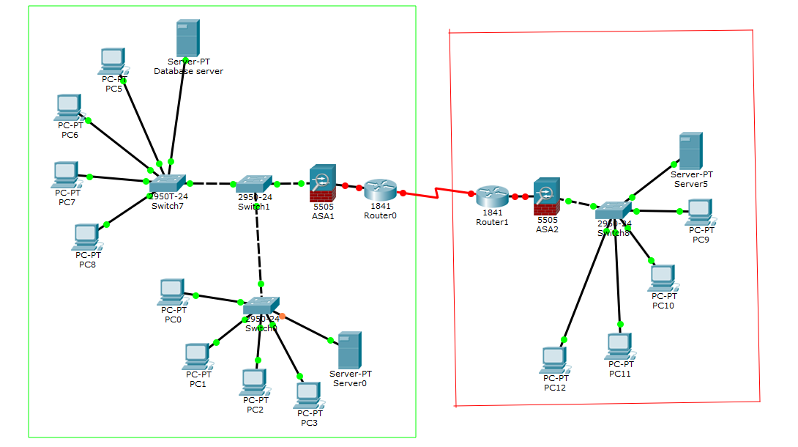

In this system architecture, we can see there are two main areas: red area for Pearl Delta Delta Region, green area for Hong Kong. As Hong Kong has two retail stores, so Hong Kong has two Database Servers.

The firewalls have been set up between the local network, each shop has a database server, it can backup for each other server data, if a database server lost the data, they can find the backup at another database server.

### 6.1.4 Benefits

#### 1. Minimize the Data inconsistency and reduce data redundancy

a centralized database system can store any store data. After replacing the current system, staff can get the correct data in the centralized database system. Also, any data changes will be done at the database system, so it can reduce data redundancy.

#### 2. Data Protection

Since the database system is connected to the internet, and Better Limited extending their business, we should install a firewall to protect the data.

The firewall will be able to block unauthorized access from external sources, reducing virus intrusion.

#### 3. Predict sales increasing product

database system will store all data, use the system to automatically warn managers that the item was close to or below the re-order level. This system can prevent the issue of inventory shortage. Also, it can have better information for business decisions because they know which products are good or bad selling via a database system.

#### 4. Reduce the paper used and more efficient

The current system is not a computerized system, after building up the computerized system, it can reduce the paper.

Sales representatives frequently work on sales to see if the stock matches with sales and inform the sales manager. If the stock level is too low, the sales manager will decide the amount required and send the request to the inventory department. It is a waste of time. After the system is built up, all data changes will be done at the database system, to be more efficient.

## 

## 6.2 Constraints and Limitations

### 6.2.1 Database Analysis

After the centralized database system build up, the company should insert the previous data into the database system but it is difficult, because the previous data is very big, and any previous data are hand-written,

If we do not insert the previous data, the database system will not have the past data to analysis the company exclusive product, via the software

### 6.2.2 Cost increase

Better Limited currently has not a complete computerized system, and now will build up a new one. So, to build up a computerized system, we need to purchase hardware or software such as a new database server, computer, firewall etc. After building up the system, we need to hire some IT staff to operate the system. If the system has something wrong, the IT staff can handle this, and there will be a yearly major maintenance operation by the IT staff.

### 6.2.3 Stabilize computerized system

Better Limited currently has not a complete computerized system. After the new one is built up, the company will be network dependent, any data changes via the computerized system, if the computer system has any error, the company department can not do anything.

## 

## 6.3 System Analysis and Design

### 6.3.1 Actor Description, Use case diagram and description

#### Actor Description

|  |  |
| --- | --- |
| **Actor Name** | **Description** |
| Sales representative | Sales representative is the frontline staff of Better Limited, the current system can not help them finish their work easily. The system will have some functions for them such as placing orders and finishing some daily work easily. |
| Sales Manager | Sales Manager is sales department staff that can manage a store inventory. They are responsible for managing the store’s stock, and decide the product price or necessary. Also, they are responsible to tidy up documents and messages with the company. |
| Inventory Clerk | Inventory Clerk is a staff who is responsible for keeping track of and managing product information and stock information in warehouse and store. Also, they are responsible to arrange the delivery mission while delivery is required by the customer. |
| Purchase Manager | Purchase Manager is a staff who works in the purchase department. They are responsible for managing purchase requests and organize a list of purchase products to send to the Inventory department for confirmation. |
| Accounting Manager | Accounting Manager is a staff who is responsible for analysis preparation of business activity, financial forecasts and annual budgets. And make an accounting report. |
| CEO | CEO are responsible for managing a company’s overall operations. This includes all functions in the company. Also, they allow us to manage employee lists. |
| Information Technology Officer | Information Technology Officer are responsible to manage the system's actor permission and oversee the system’s log to ensure no big problem happens or find out the problem. |
| Technical Support Clerk | Technical Support Clerk is responsible to manage installation services with customers while installation is required. |

#### 

#### Use case list

|  |  |  |
| --- | --- | --- |
| **Use Case ID** | **Use Case Name** | **Primary Actor** |
| UC-002 | Login | All user |
| UC-003 | Place Order | Sales representative |
| UC-004 | View Inventory | Sales representative,  Sales Manager,  Inventory Clerk,  Purchase Manager,  Accounting Manager,  CEO |
| UC-005 | Create re-stock request | Sales Manager |
| UC-006 | Update product stock | Sales Manager,  Inventory Clerk |
| UC-007 | View product detail | Sales Manager,  Inventory Clerk,  Purchase Manager,  Accounting Manager,  CEO |
| UC-008 | Edit product detail | Sales Manager,  Inventory Clerk,  Purchase Manager,  Accounting Manager,  CEO |
| UC-009 | Add new product | Inventory Clerk |
| UC-010 | Delete product | Inventory Clerk |
| UC-011 | View Document | All user |
| UC-012 | Download document | All user |
| UC-013 | Upload document | All user |
| UC-014 | Print document | All user |
| UC-015 | View sales report | Sales representative |
| UC-016 | View monthly sales data | Sales representative |
| UC-017 | View Message | All user |
| UC-018 | Send message | All user |
| UC-019 | Create Delivery/Installation Request | Sales Representative |
| UC-020 | View Delivery/Installation Schedule | Sales Representative |
| UC-021 | Create Purchase Request | Inventory Clerk |
| UC-022 | View Delivery Schedule | Inventory Clerk |
| UC-023 | View day delivery detail | Inventory Clerk |
| UC-024 | Arrange Delivery mission | Inventory Clerk |
| UC-025 | Cancel Delivery mission | Inventory Clerk |
| UC-026 | Generate Delivery note | Inventory Clerk |
| UC-027 | Generate Goods returned note | Inventory Clerk |
| UC-028 | Generate Goods received note | Inventory Clerk |
| UC-029 | Generate Accounting Report | Accounting Manager |
| UC-030 | Approve Purchase Request | Purchase Manager |
| UC-031 | View System Logs | Information Technology Officer |
| UC-032 | Arrange permission | Information Technology Officer |
| UC-033 | View Installation Schedule | Technical Support Clerk |
| UC-034 | Arrange Installation mission | Technical Support Clerk |
| UC-035 | Cancel Installation mission | Technical Support Clerk |
| UC-036 | Generate Installation note | Technical Support Clerk |
| UC-037 | View day Installation Detail | Technical Support Clerk |
| UC-038 | View Employee List | CEO |
| UC-039 | Add new employee | CEO |
| UC-040 | Update employee status | CEO |

#### 

#### Use case description

|  |  |
| --- | --- |
| **Use Case name** | Login |
| **Use case ID** | UC-002 |
| **Actor(s)** | Sales representative, Sales Manager, Inventory Clerk, Purchase Manager, Accounting Manager, CEO, Information Technology Officer, Technical Support Clerk |
| **Brief description** | Login system by entering staff ID and password for getting the permission |
| **Precondition** | Users register an account by input staff ID, password and choose the department. |
| **Trigger** | None |
| **Basic Flow** | 1. User input staff ID and password, click login button.  2. System verifies the staff ID and password, according to the user department to display their own menu of the management system. |
| **Alternate Flows** | In step 2, if the user cannot through the verification, the system will display an error message and let the user login again. |

|  |  |
| --- | --- |
| **Use Case name** | Place order |
| **Use case ID** | UC-003 |
| **Actor(s)** | Sales representative |
| **Brief description** | Add product to cart which is customer required product, when user helps customer checkout the cart, system will place order. |
| **Precondition** | Login as Sales department staff |
| **Trigger** | Sales Department menu - “In-store” button |
| **Basic Flow** | 1. User search product and choose Qty and click the “add” button.  2. System add product into cart.  3. Users click the “Checkout” button to place an order.  4. System notify user the order ID. |
| **Alternate Flows** | In step 3, if the cart has no product here, the system will display an error message. |

|  |  |
| --- | --- |
| **Use Case name** | View Inventory |
| **Use case ID** | UC-004 |
| **Actor(s)** | Sales representative, Sales Manager, Inventory Clerk, Purchase Manager, Accounting Manager, CEO |
| **Brief description** | View the inventory of all product |
| **Precondition** | Login as Sales department or Inventory department or purchase department or Accounting department or CEO |
| **Trigger** | Sales department menu - “Inventory Management” button,  Inventory department menu - “Inventory Management” button,  Purchase department menu - “Inventory Management” button,  Accounting department menu - “Inventory Management” button,  CEO menu -”Inventory Management” button |
| **Basic Flow** | 1. System display list of all product  2. User input product ID or product name and click “search” button  3. System display match product information |
| **Alternate Flows** | In step 2, if the user input wrong product ID or wrong product name, the system will display the error message. |

|  |  |
| --- | --- |
| **Use Case name** | Create re-stock request |
| **Use case ID** | UC-005 |
| **Actor(s)** | Sales Manager |
| **Brief description** | Create the re-stock request to Inventory department |
| **Precondition** | Login as Sales Manager. |
| **Trigger** | Inventory Management - “create re-stock request” button |
| **Basic Flow** | 1. User select store number, input product ID and product name and re-stock Qty, then click the “Submit” button  2. System will show a submit success message for the user and send a request to the Inventory department. |
| **Alternate Flows** | In step 1, if the user is missing input, the system will notify them that they need to input missing data. |

|  |  |
| --- | --- |
| **Use Case name** | Update Product Stock |
| **Use case ID** | UC-006 |
| **Actor(s)** | Sales Manager, Inventory Clerk |
| **Brief description** | Update the product stock status |
| **Precondition** | Login as Sales Manager, Inventory Clerk |
| **Trigger** | Inventory Management - “Update stock” button |
| **Basic Flow** | 1. System ask user to input product ID, product name, inventory quantity and choose store 1, 2 or warehouse  2. User input product ID, name, inventory Quantity and choose store1 or store 2 or warehouse to update stock status, click the “Submit” button  3. System update the stock information according Product ID and display “Inventory Management” page |
| **Alternate Flows** | In step 2, if the user is missing input, the system will notify them that they need to input missing data. |

|  |  |
| --- | --- |
| **Use Case name** | View product detail |
| **Use case ID** | UC-007 |
| **Actor(s)** | Sales representative, Sales Manager, Inventory Clerk, Purchase Manager, Accounting Manager, CEO |
| **Brief description** | View the product detail information such as re-stock level and necessary status |
| **Precondition** | Login as Sales representative, Sales Manager, Inventory Clerk, Purchase Manager, Accounting Manager or CEO |
| **Trigger** | Double Click the product on Inventory Management product list. |
| **Basic Flow** | 1. System displays the product detail information including Product ID, Product Name, Supplier, Category, Re-stock level, Re-stock Qty, Unit price and Necessary status. |
| **Alternate Flows** | None |

|  |  |
| --- | --- |
| **Use Case name** | Edit product detail |
| **Use case ID** | UC-008 |
| **Actor(s)** | Sales representative, Sales Manager, Inventory Clerk, Purchase Manager, Accounting Manager, CEO |
| **Brief description** | Edit the product re-stock level, re-stock Qty, Unit price and necessary status. |
| **Precondition** | Login as Sales representative,  Sales Manager, Inventory Clerk, Purchase Manager, Accounting Manager or CEO |
| **Trigger** | Product Detail - “Update” button |
| **Basic Flow** | 1. User select the product in Inventory Management page and double click the product  2. System display the Product Detail page  3. User click the “Update” button  4. System display the current information of product  5. User edit the info of product such as re-stock level, re-stock Qty and Unit price and tick with necessary  6. System update the product information |
| **Alternate Flows** | None |

|  |  |
| --- | --- |
| **Use Case name** | Add new product |
| **Use case ID** | UC-009 |
| **Actor(s)** | Inventory Clerk |
| **Brief description** | Add new product into Inventory Management |
| **Precondition** | Login as Inventory Clerk |
| **Trigger** | Inventory Management - “add new product” button |
| **Basic Flow** | 1. User click “add new product” button in Inventory Management page  2. System display new product information form  3. User fill in all of form information  (Product ID, Category, Product name, Supplier, Unit Price, re-stock level and re-stock Qty) and click “Submit” button  4. System display “add new product success” message |
| **Alternate Flows** | In step 2, if user missing input, system will alert them input missing information |

|  |  |
| --- | --- |
| **Use Case name** | Delete product |
| **Use case ID** | UC-010 |
| **Actor(s)** | Inventory Clerk |
| **Brief description** | Remove product from database which are no longer available for sale |
| **Precondition** | Login as Inventory Clerk |
| **Trigger** | Product Detail page -”Delete” button |
| **Basic Flow** | 1. User select the product at Inventory Management product list and double click the product  2. System display Product Detail page  3. User click “Delete” button  4. System display alert message confirm delete product  5. User click “Confirm” button  6. System delete the product information in database. |
| **Alternate Flows** | None |

|  |  |
| --- | --- |
| **Use Case name** | View Document |
| **Use case ID** | UC-011 |
| **Actor(s)** | Sales representative, Sales Manager, Inventory Clerk, Purchase Manager, Accounting Manager, CEO, Information Technology Officer, Technical Support Clerk |
| **Brief description** | View Document in the database. |
| **Precondition** | Login as Sales representative,  Sales Manager, Inventory Clerk, Purchase Manager, Accounting Manager, CEO, Information Technology Officer, Technical Support Clerk |
| **Trigger** | Sales department menu - “Document Management” button,  Inventory department menu - “Document Management” button,  Purchase department menu - “Document Management” button,  Accounting department menu - “Document Management” button,  CEO menu -”Document Management” button  Information Technology department menu - “Document Management” button  Technical Support department menu - “Document Management” button |
| **Basic Flow** | 1. User click the “Document Management” button on their own menu  2. System list out all folder and file  3. User select the pdf file  4. System show pdf file content on “Preview” window |
| **Alternate Flows** | None |

|  |  |
| --- | --- |
| **Use Case name** | Download Document |
| **Use case ID** | UC-012 |
| **Actor(s)** | Sales representative, Sales Manager, Inventory Clerk, Purchase Manager, Accounting Manager, CEO, Information Technology Officer, Technical Support Clerk |
| **Brief description** | Download the documents to own PC |
| **Precondition** | Login as Sales representative,  Sales Manager, Inventory Clerk, Purchase Manager, Accounting Manager, CEO, Information Technology Officer, Technical Support Clerk |
| **Trigger** | Document Management - “Download” button |
| **Basic Flow** | 1. User select file on Document Management Document list and click “Download” button  2. System display the download started message |
| **Alternate Flows** | In step 1, if user selected is folder, system will alert user select valid file |

|  |  |
| --- | --- |
| **Use Case name** | Upload File |
| **Use case ID** | UC-013 |
| **Actor(s)** | Sales representative, Sales Manager, Inventory Clerk, Purchase Manager, Accounting Manager, CEO, Information Technology Officer, Technical Support Clerk |
| **Brief description** | Upload file to Document Management. |
| **Precondition** | Login as Sales representative,  Sales Manager, Inventory Clerk, Purchase Manager, Accounting Manager, CEO, Information Technology Officer, Technical Support Clerk |
| **Trigger** | Document Management - “upload” button |
| **Basic Flow** | 1. User click the “upload” button on Document Management page  2. System display the file upload page  3. User click the black area to upload file and choose which folder on Document Management he wants to upload to, then click the “Upload” button  4. System received file and save it to selected folder |
| **Alternate Flows** | In step 3, if the user uploads a file size is bigger than 32MB, the system will display the error message to the user. |

|  |  |
| --- | --- |
| **Use Case name** | Print Document |
| **Use case ID** | UC-014 |
| **Actor(s)** | Sales representative, Sales Manager, Inventory Clerk, Purchase Manager, Accounting Manager, CEO, Information Technology Officer, Technical Support Clerk |
| **Brief description** | Print out the selected file. |
| **Precondition** | Login as Sales representative,  Sales Manager, Inventory Clerk, Purchase Manager, Accounting Manager, CEO, Information Technology Officer, Technical Support Clerk |
| **Trigger** | Document Management - “print” button |
| **Basic Flow** | 1. User select file on Document Management page and click “print” button  2. System display “print success” message |
| **Alternate Flows** | In step 1, if a user selects an invalid file such as a folder, the system displays the message to notify the user to select a valid file. |

|  |  |
| --- | --- |
| **Use Case name** | View Sales report |
| **Use case ID** | UC-015 |
| **Actor(s)** | Sales representative |
| **Brief description** | View the Sales monthly sales or Quarter sales or year sales |
| **Precondition** | Login as Sales representative |
| **Trigger** | Sales Department menu - “Monthly Report” button |
| **Basic Flow** | 1. User click the “Monthly Report” button  2. System list out the Total sales by Monthly |
| **Alternate Flows** | None |

|  |  |
| --- | --- |
| **Use Case name** | View monthly sales data |
| **Use case ID** | UC-016 |
| **Actor(s)** | Sales representative |
| **Brief description** | View the data about monthly sales |
| **Precondition** | Login as Sales representative |
| **Trigger** | Monthly Report - “Sales Data” button |
| **Basic Flow** | 1. User select the month on the Monthly Sales Report list and click “Sales Data” button  2. System display the sales representative name, store, sales Date, sold product ID and Total sales amount |
| **Alternate Flows** | None |

|  |  |
| --- | --- |
| **Use Case name** | View Message |
| **Use case ID** | UC-017 |
| **Actor(s)** | Sales representative, Sales Manager, Inventory Clerk, Purchase Manager, Accounting Manager, CEO, Information Technology Officer, Technical Support Clerk |
| **Brief description** | View the message within company |
| **Precondition** | Login as Sales representative,  Sales Manager, Inventory Clerk, Purchase Manager, Accounting Manager, CEO, Information Technology Officer, Technical Support Clerk |
| **Trigger** | Sales department menu -  “Message” button,  Inventory department menu - “Message” button,  Purchase department menu - “Message” button,  Accounting department menu - “Message” button,  CEO menu - “Message” button  Information Technology department menu - “Message” button  Technical Support department menu - “Message” button |
| **Basic Flow** | 1. User click the “Message” button on their own department menu  2. System will display All message and message window  3. User input keyword in Search Message textbox  4. System will display message history which match user’s input text |
| **Alternate Flows** | None |

|  |  |
| --- | --- |
| **Use Case name** | Send Message |
| **Use case ID** | UC-018 |
| **Actor(s)** | Sales representative, Sales Manager, Inventory Clerk, Purchase Manager, Accounting Manager, CEO, Information Technology Officer, Technical Support Clerk |
| **Brief description** | Send message to other one |
| **Precondition** | Login as Sales representative,  Sales Manager, Inventory Clerk, Purchase Manager, Accounting Manager, CEO, Information Technology Officer, Technical Support Clerk |
| **Trigger** | Message - “Send ” button |
| **Basic Flow** | 1. User select the people and input text in text box “Please input message” and click “Send” button  2. System will send message to selected people |
| **Alternate Flows** | None |

|  |  |
| --- | --- |
| **Use Case name** | Create Delivery/Installation Request |
| **Use case ID** | UC-019 |
| **Actor(s)** | Sales representative |
| **Brief description** | Create the delivery/installation request send to Inventory Department |
| **Precondition** | Login as Sales representative |
| **Trigger** | Sales Department menu - “Create Delivery/Installation Request” button |
| **Basic Flow** | 1. User click the “Create Delivery/Installation Request” button  2. System display the Create Delivery/Installation Request form  3. User fill in the Order ID, Address, check Delivery needs, check Installation needs and click “Submit” button  4. System will send request to Inventory Department |
| **Alternate Flows** | In step 3, if a user is missing input, the system will notify them that they need to input missing information. |

|  |  |
| --- | --- |
| **Use Case name** | View Delivery/Installation Schedule |
| **Use case ID** | UC-020 |
| **Actor(s)** | Sales representative |
| **Brief description** | View the delivery and installation schedule available |
| **Precondition** | Login as Sales representative |
| **Trigger** | Sales Department - ”Delivery/Installation Schedule” button |
| **Basic Flow** | 1. User click” Delivery/Installation Schedule” button  2. System displays two calendars, left side is delivery schedule, right side is Installation schedule |
| **Alternate Flows** | None |

|  |  |
| --- | --- |
| **Use Case name** | Create Purchase Request |
| **Use case ID** | UC-021 |
| **Actor(s)** | Inventory Clerk |
| **Brief description** | Create purchase request and send to purchase department |
| **Precondition** | Login as Inventory Clerk |
| **Trigger** | Inventory Department menu - “Purchase Request” button |
| **Basic Flow** | 1. User click “Purchase Request” button  2. System show all product list and information  3. User tick the left side checkbox if product is needed and click “Submit” button  4. System will send request to purchase department |
| **Alternate Flows** | In step 3, if the user doesn't tick any checkbox and click the “Submit” button, the system will display an error message. |

|  |  |
| --- | --- |
| **Use Case name** | View Delivery Schedule |
| **Use case ID** | UC-022 |
| **Actor(s)** | Inventory Clerk |
| **Brief description** | View the delivery schedule calendar |
| **Precondition** | Login as Inventory Clerk |
| **Trigger** | Inventory Department menu - “Delivery Schedule” button |
| **Basic Flow** | 1. User click the “Delivery Schedule” button  2. System display the calendar |
| **Alternate Flows** | None |

|  |  |
| --- | --- |
| **Use Case name** | View day delivery detail |
| **Use case ID** | UC-023 |
| **Actor(s)** | Inventory Clerk |
| **Brief description** | View day delivery detail information in different time |
| **Precondition** | Login as Inventory Clerk |
| **Trigger** | Delivery Schedule - “Day Delivery Detail” button |
| **Basic Flow** | 1. User select a day in calendar and click “Day Delivery Detail” button  2. System will list out all the delivery missions on selected day |
| **Alternate Flows** | None |

|  |  |
| --- | --- |
| **Use Case name** | Arrange Delivery mission |
| **Use case ID** | UC-024 |
| **Actor(s)** | Inventory Clerk |
| **Brief description** | Arrange the awaiting arrangement delivery request |
| **Precondition** | Login as Inventory Clerk |
| **Trigger** | Awaiting Arrangement - “Arrange” button |
| **Basic Flow** | 1. User click “Awaiting Arrangement” button on Delivery Schedule page  2. System list all Awaiting Arrangement order  3. User select Awaiting order and click “Arrange” button  4. System display Arrange Delivery form to user  5. User select the date and time, workman in that time and click “Submit” button  6. System will upload new delivery mission to schedule |
| **Alternate Flows** | In step 5, if the user selected a not free workman, the system will alert the user to choose another workman.  In step 4, if user click the “Cancel” button, user will back to delivery schedule page |

|  |  |
| --- | --- |
| **Use Case name** | Cancel Delivery mission |
| **Use case ID** | UC-025 |
| **Actor(s)** | Inventory Clerk |
| **Brief description** | Cancel the arranged delivery mission |
| **Precondition** | Login as Inventory Clerk |
| **Trigger** | Day Delivery Detail - “Delivery Cancel” button |
| **Basic Flow** | 1. User select a day in calendar on Delivery Schedule page and click “Day Delivery Detail” button  2. System list out all arranged mission in selected day  3. User select a delivery mission and click “Delivery Cancel” button  4. System will remove the selected delivery mission on the list and schedule |
| **Alternate Flows** | None |

|  |  |
| --- | --- |
| **Use Case name** | Generate Delivery note |
| **Use case ID** | UC-026 |
| **Actor(s)** | Inventory Clerk |
| **Brief description** | Generate delivery note for Inventory department, van driver and customer |
| **Precondition** | Login as Inventory Clerk |
| **Trigger** | Day Delivery Detail - “Generate Note” button |
| **Basic Flow** | 1. User select a day in calendar on Delivery Schedule page and click “Day Delivery Detail” button  2. System list out all arranged mission in selected day  3. User select a delivery mission and click “Generate Note” button  4. System will writes out the report for Inventory Department, van driver and customer |
| **Alternate Flows** | None |

|  |  |
| --- | --- |
| **Use Case name** | Generate Goods returned note |
| **Use case ID** | UC-027 |
| **Actor(s)** | Inventory Clerk |
| **Brief description** | Generate the Goods returned note which goods return from customer |
| **Precondition** | Login as Inventory Clerk |
| **Trigger** | Goods returned note - “Generate” button |
| **Basic Flow** | 1. User click “Goods Returned Note” button on Inventory Department menu  2. System display Goods Returned Note form  3. User fill the information (Customer Name, Address, Phone, add product) and click “Generate” button  4. System writes out the Goods Returned Note |
| **Alternate Flows** | In step 3, if user don’t have add the product and click the “Generate” button, system will display the error message |

|  |  |
| --- | --- |
| **Use Case name** | Generate Goods received note |
| **Use case ID** | UC-028 |
| **Actor(s)** | Inventory Clerk |
| **Brief description** | Generate the Goods received note which the Inventory Department needs to receive. |
| **Precondition** | Login as Inventory Clerk |
| **Trigger** | Goods Received Note - “Generate” button |
| **Basic Flow** | 1. User click the “Goods Received Note” button on Inventory Department  2. System display the Goods Received Note form  3. User fill the information (Purchase Order ID, Supplier, Date goods received) and click “Generate” button  4. System writes out the Goods Received Note |
| **Alternate Flows** | In step 3, if the user missing input, system will alert user to input missing information |

|  |  |
| --- | --- |
| **Use Case name** | Generate Accounting Report |
| **Use case ID** | UC-029 |
| **Actor(s)** | Accounting Manager |
| **Brief description** | Generate the accounting report for manager to analyze the sales activities |
| **Precondition** | Login as Accounting Manager |
| **Trigger** | Accounting Report - “Generate” button |
| **Basic Flow** | 1. User click the “Accounting Report” button on Accounting Department menu  2. System will show the accounting report about month and total profit or loss  3. User select the month and click “Generate” button  4. System writes out the Accounting report |
| **Alternate Flows** | In step 3, if user selected year or Quarter, system will alert user to choose month |

|  |  |
| --- | --- |
| **Use Case name** | Approve Purchase Request |
| **Use case ID** | UC-030 |
| **Actor(s)** | Purchase Manager |
| **Brief description** | Approve Purchase Request which from Inventory department required |
| **Precondition** | Login as Purchase Manager |
| **Trigger** | Approval Purchase Request - “Approve” button |
| **Basic Flow** | 1. User click “Approval Purchase Request” button on menu  2. System display all awaiting purchase request and show product ID, Qty and phasing-out status  3. User select Awaiting Sequence number and click “Approve” button  4. System display dialog to notify user purchase order is created  5. User click “Confirm” button |
| **Alternate Flows** | In step 3, if user select Sequence number and click “reject” button, system will delete the request and send reject message to Inventory Department |

|  |  |
| --- | --- |
| **Use Case name** | View System Logs |
| **Use case ID** | UC-031 |
| **Actor(s)** | Information Technology Officer |
| **Brief description** | View system logs, all user tasks and logs |
| **Precondition** | Login as Information Technology Officer |
| **Trigger** | Information Technology Department menu - “System Logs” button |
| **Basic Flow** | 1. User click “System Logs” button on menu  2. System will list out all System logs and user logs with date and time |
| **Alternate Flows** | None |

|  |  |
| --- | --- |
| **Use Case name** | Arrange Permission |
| **Use case ID** | UC-032 |
| **Actor(s)** | Information Technology Officer |
| **Brief description** | Arrange different permission for different position staff |
| **Precondition** | Login as Information Technology Officer |
| **Trigger** | Information Technology Department menu - ”Arrange Permission” button |
| **Basic Flow** | 1. User click the “Arrange Permission” button on menu  2. System displays all position staff and their system permission such as read, write, execute and manage.  3. User tick the checkbox if staff need that permission and click “Confirm” button  4. System will setup staff’s permission |
| **Alternate Flows** | In step 3, if user click “Reset” button, all permission will be reset to all staff have all permission |

|  |  |
| --- | --- |
| **Use Case name** | View Installation Schedule |
| **Use case ID** | UC-033 |
| **Actor(s)** | Technical Support Clerk |
| **Brief description** | View installation mission schedule |
| **Precondition** | Login as Technical Support Clerk |
| **Trigger** | Technical Support Department menu - “Installation Schedule” button |
| **Basic Flow** | 1. User click the “Installation Schedule” button on menu  2. System display the installation calendar |
| **Alternate Flows** | None |

|  |  |
| --- | --- |
| **Use Case name** | Arrange Installation mission |
| **Use case ID** | UC-034 |
| **Actor(s)** | Technical Support Clerk |
| **Brief description** | Arrange the installation request order to workman |
| **Precondition** | Login as Technical Support Clerk |
| **Trigger** | Arrange Installation Page - “Submit” button |
| **Basic Flow** | 1. User click the “Installation Schedule” button on menu  2. System display the installation calendar and two button “Awaiting Arrangement” and “Day Installation Detail”  3. User click “Awaiting Arrangement” button  4. System will list out all awaiting arrangement installation order  5. User select the order and click “Arrange” button  6. System display the Arrange Installation form and auto fill in the Order ID, Address, Phone and Delivery date and time  7. User select the installation date and time, select the workman and click “Submit” button  8. System will arrange the installation |
| **Alternate Flows** | · In step 7, if the installation date and time selected by the user is not at least 2 hours after the delivery date and time, system will display the error message and user need to select installation time again.  · In step 7, if user selected not free workman in that installation time, system will alert user. |

|  |  |
| --- | --- |
| **Use Case name** | Cancel Installation mission |
| **Use case ID** | UC-035 |
| **Actor(s)** | Technical Support Clerk |
| **Brief description** | Cancel the arranged installation mission |
| **Precondition** | Login as Technical Support Clerk |
| **Trigger** | Day Installation Detail - “Installation Cancel” button |
| **Basic Flow** | 1. User select a day on Installation Schedule page and click “Day Installation Detail” button  2. System display all installation mission on selected day  3. User select a installation mission and click “Installation Cancel” button” |
| **Alternate Flows** | None |

|  |  |
| --- | --- |
| **Use Case name** | Generate Installation Note |
| **Use case ID** | UC-036 |
| **Actor(s)** | Technical Support Clerk |
| **Brief description** | Generate Installation Note for staff and customer |
| **Precondition** | Login as Technical Support Clerk |
| **Trigger** | Day Installation Detail - “Generate Note” button |
| **Basic Flow** | 1. User select a day on Installation Schedule page and click “Day Installation Detail” button  2. System display all installation mission on selected day  3. User select a installation mission and click “Installation Cancel” button”  4. System writes out a installation note |
| **Alternate Flows** | None |

|  |  |
| --- | --- |
| **Use Case name** | View Day Installation Detail |
| **Use case ID** | UC-037 |
| **Actor(s)** | Technical Support Clerk |
| **Brief description** | View all installation mission on selected day |
| **Precondition** | Login as Technical Support Clerk |
| **Trigger** | Installation Schedule - “Day Installation Detail” |
| **Basic Flow** | 1. User click “Installation Schedule” button on menu  2. System display calendar and two button  3. User select a day on calendar and click “Day Installation Detail” button  4. System display a list and list out all installation mission on selected day |
| **Alternate Flows** | · In step 3, if user selected a date in the past, system will display a error message. |

|  |  |
| --- | --- |
| **Use Case name** | View Employee List |
| **Use case ID** | UC-038 |
| **Actor(s)** | CEO |
| **Brief description** | View all hired employee |
| **Precondition** | Login as CEO |
| **Trigger** | CEO menu - “Employee” button |
| **Basic Flow** | 1. CEO click “Employee” button on CEO menu  2. System will list out all employee information(Staff ID, Staff name, department, position and hiring date) |
| **Alternate Flows** | None |

|  |  |
| --- | --- |
| **Use Case name** | Add new employee |
| **Use case ID** | UC-039 |
| **Actor(s)** | CEO |
| **Brief description** | Add new employee to system |
| **Precondition** | Login as CEO |
| **Trigger** | Employee page - “add new employee” button |
| **Basic Flow** | 1. CEO click “Employee” button on CEO menu  2. System will list out all employee information(Staff ID, Staff name, department, position and hiring date)  3. User click “add new employee” button  4. System display “Add new employee” form  5. User fill the new employee information( Staff name, select Department, select position and select hiring date) and click “Add” button  6. System display a new staff notification and auto arrange a staff ID for new staff.  7. User click “Confirm” button  8. System added new employee to list |
| **Alternate Flows** | · In step 5, if user click “Cancel” button, all filled data will be empty and back to employee page |

|  |  |
| --- | --- |
| **Use Case name** | Update employee status |
| **Use case ID** | UC-040 |
| **Actor(s)** | CEO |
| **Brief description** | Update a staff status |
| **Precondition** | Login as CEO |
| **Trigger** | Employee - “Update Employee status” button |
| **Basic Flow** | 1. CEO click “Employee” button on CEO menu  2. System will list out all employee information(Staff ID, Staff name, department, position and hiring date)  3. User select a employee and click “Update Employee status” button  4. System display the form with filled Staff ID, staff name, current department and position and hiring date of selected employee.  5. User select department and position. Click “Update” button  6. System will update staff status |
| **Alternate Flows** | None |

#### Use case diagram

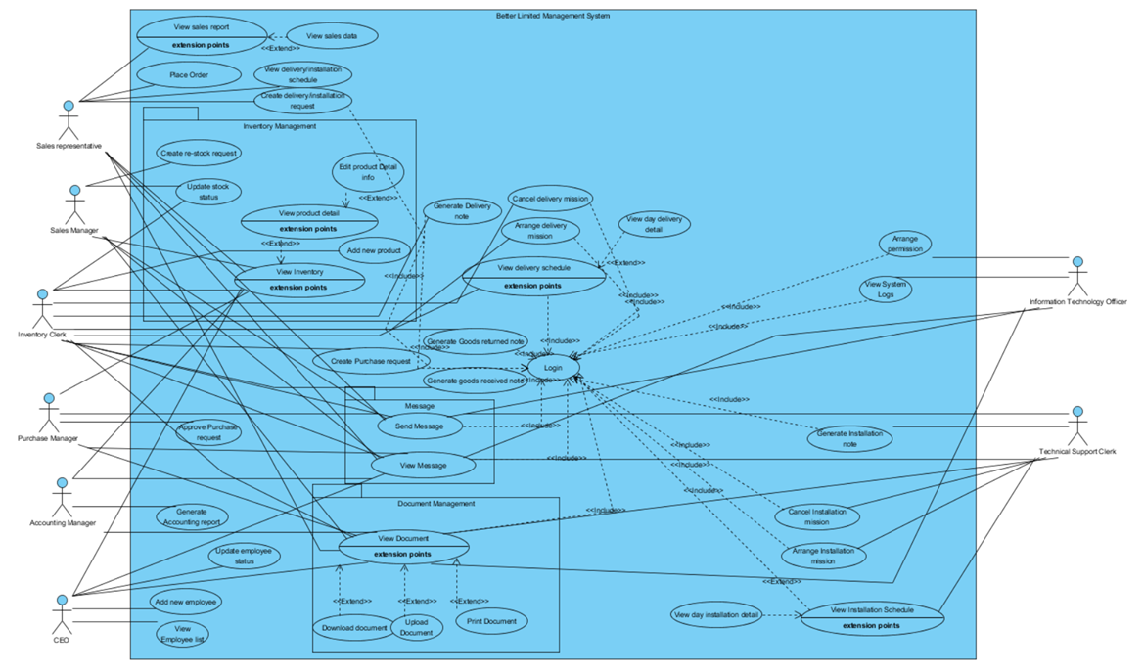

### 6.3.2 Class Diagram (Design Level)

|  |
| --- |
|  |

### 6.3.3 Sequence Diagram

|  |
| --- |
| UC002 : |
| UC003 : |
| UC004 : |
| UC005 : |
| UC006 : |
| UC007 : |
| UC008 : |
| UC009 : |
| UC010 : |
| UC011 : |
| UC012 : |
| UC013 : |
| UC014 : |
| UC015 : |
| UC016 : |
| UC017 : |
| UC018 : |
| UC019 : |
| UC020 : |
| UC021 : |
| UC022 : |
| UC023 : |
| UC024 : |
| UC025 : |
| UC026 : |
| UC027 : |
| UC028 : |
| UC029 : |
| UC030 : |
| UC031 : |
| UC032 : |
| UC033 : |
| UC034 : |
| UC035 : |
| UC036 : |
| UC037 : |
| UC038 : |
| UC039 : |
| UC040 : |

## 

## 6.4 Entity Relation Diagram (ERD)

|  |
| --- |
|  |

## 

## 6.5 Database Design

|  |  |  |  |
| --- | --- | --- | --- |
| **Table name: staff**  **Primary key: staffID** | | | |
| **Column name** | **Data type** | **Null/not null** | **description** |
| staffID | Integer(6) | Not null | The ID of staff |
| staffName | Varchar(20) | Not null | The name of staff |
| phoneNo | Integer(8) | Not null | The phone number of staff |
| email | Varchar(35) | Not null | The email address of the staff |
| position | Varchar(15) | Not null | The position of the staff |
| salary | Integer(6) | Not null | The month salary of staff |

|  |  |  |  |
| --- | --- | --- | --- |
| **Table name: inventory**  **Primary key: itemID** | | | |
| **Column name** | **Data type** | **Null/not null** | **description** |
| itemID | Integer(6) | Not null | The ID of the order |
| qty | Integer(5) | Not null | The quantity of item that the order need |
| sutitableQty | Integer(5) | Not null | The quantity of each item that should be in stock |
| reorderQty | Integer(5) | Not null | When the quantity of items reaches the set number, it should be replenished |

|  |  |  |  |
| --- | --- | --- | --- |
| **Table name: department**  **Primary key: departmentID**  **Foreign key:staff.staffID** | | | |
| **Column name** | **Data type** | **Null/not null** | **description** |
| deptID | Integer(6) | Not null | The ID of department |
| deptName | Varchar(20) | Not null | The name of department |
| numberOfStaff | Integer(3) | Not null | The number of department |
| deptPhoneNo | Integer(8) | Not null | The phone number of department |
| staffID | Integer(6) | Not null | The name of the staff of department |

|  |  |  |  |
| --- | --- | --- | --- |
| **Table name: staffAccount**  **Primary key: staffID, userName**  **Foreign key: staff.phoneNo, staff.email, staff.position** | | | |
| **Column name** | **Data type** | **Null/not null** | **description** |
| staffID | Integer(6) | Not null | The ID of staff |
| userName | Varchar(15) | Not null | The user name of the staff account |
| password | Char(10) | Not null | The password of the staff account |
| email | Varchar(35) | Not null | The email address of the the staff account |
| phoneNo | Integer(8) | Not null | The phone number of the the staff account |
| position | Varchar(15) | Not null | The position of the staff |

|  |  |  |  |
| --- | --- | --- | --- |
| **Table name: customer**  **Primary key: customerID** | | | |
| **Column name** | **Data type** | **Null/not null** | **description** |
| customerID | Integer(6) | Not null | The ID of the customer |
| customerName | Varchar(20) | Not null | The name of the customer |
| cusPhoneNo | Integer(8) | Not null | The phone number of the customer |
| cusEmail | Varchar(35) | Not null | The email address of the the customer |
| company | Varchar(40) | Null | The company of the customer |
| comPhoneNo | Integer(8) | Null | The phone number of the company |
| postcode | Integer(7) | Null | The postcode of the company |

|  |  |  |  |
| --- | --- | --- | --- |
| **Table name: order**  **Primary key: orderID**  **Foreign key: customer.customerID** | | | |
| **Column name** | **Data type** | **Null/not null** | **description** |
| orderID | Integer(6) | Not null | The ID of the order |
| orderType | Varchar(12) | Not null | The type of the order  There are three types of an order: sales/purchase/re-stock |
| customerID | Integer(6) | Not null | The ID of the customer of the order |
| orderDate | Date(8) | Not null | The order date of the the order  The date should be input as yy/mm/dd |
| totalPrice | Integer(5) | Not null | The total price of the the order |
| destination | Varchar(20) | Not null | The destination of the order |

|  |  |  |  |
| --- | --- | --- | --- |
| **Table name: receipt**  **Primary key: orderID, receiptID**  **Foreign key: order.orderID, customer.customerID** | | | |
| **Column name** | **Data type** | **Null/not null** | **description** |
| orderID | Integer(6) | Not null | The ID of the order |
| receiptID | Integer(6) | Not null | The ID of the receipt |
| receiptDate | Date(8) | Not null | The receipt date of the receipt  The date should be input as yy/mm/dd |
| customerID | Integer(6) | Not null | The ID of the customer who is the owner of the order |
| amountPaid | Integer(10) | Not null | The amount paid by the customer |

|  |  |  |  |
| --- | --- | --- | --- |
| **Table name: orderedItem**  **Primary key: orderID,itemID**  **Foreign key: order.orderID, inventory.itemID** | | | |
| **Column name** | **Data type** | **Null/not null** | **description** |
| orderID | Integer(6) | Not null | The ID of the order |
| itemID | Integer(6) | Not null | The ID of the item |
| oQty | Integer(5) | Not null | The quantity of item that the order need |

|  |  |  |  |
| --- | --- | --- | --- |
| **Table name: stockedItem**  **Primary key: inventory.itemID** | | | |
| **Column name** | **Data type** | **Null/not null** | **description** |
| itemID | Integer(6) | Not null | The ID of the item |
| itemName | Varchar(20) | Not null | The name of the item |
| price | Integer(5) | Not null | The price of the item |
| category | Varchar(20) | Not null | The category of the item  E.g. refrigerator, fan, hair dryer |

## 

## 6.6 User Interface Design

Login Page

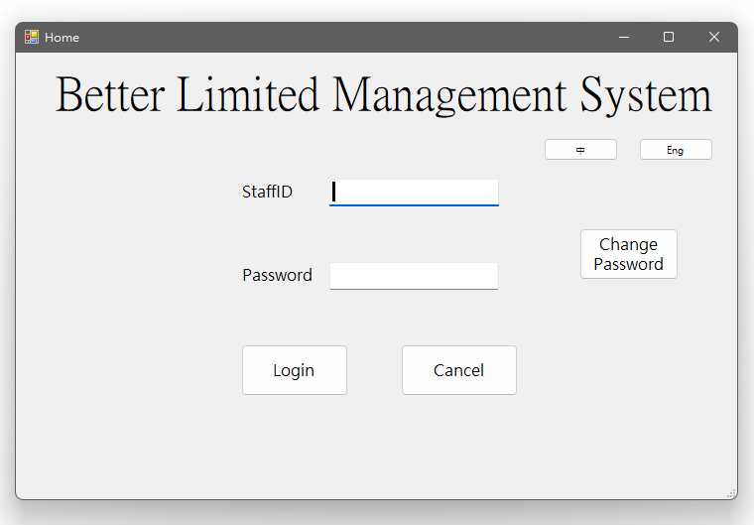

Change Password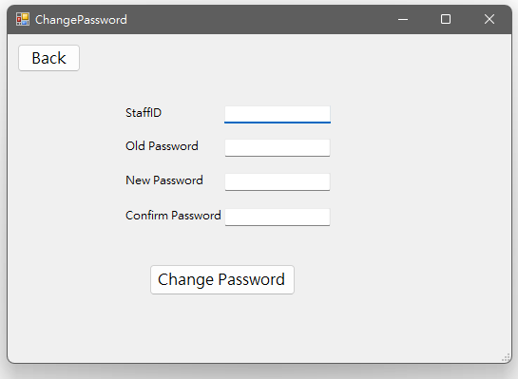

Menu (CEO)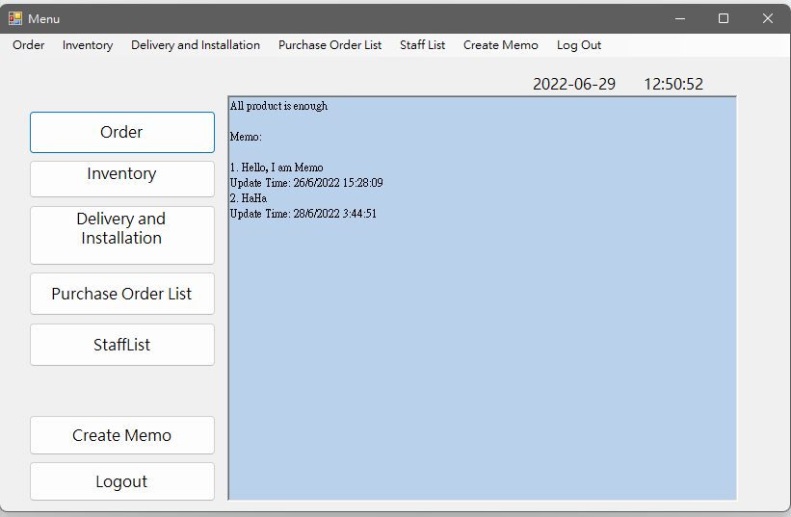

Menu (accounting, inventory, technical support staff)

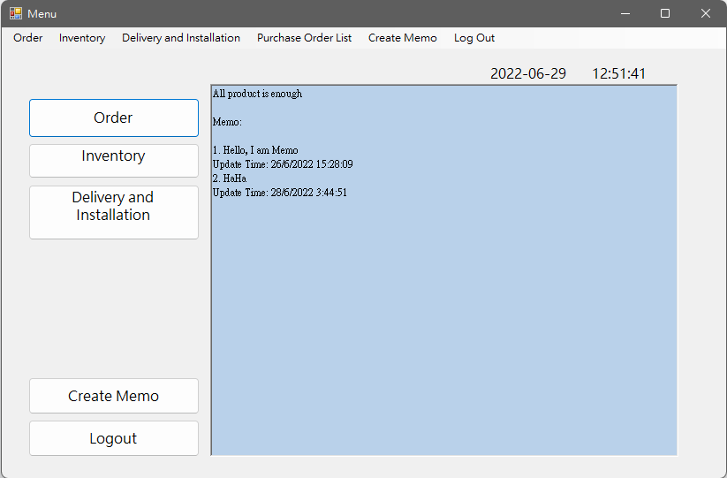

Menu (purchase staff)

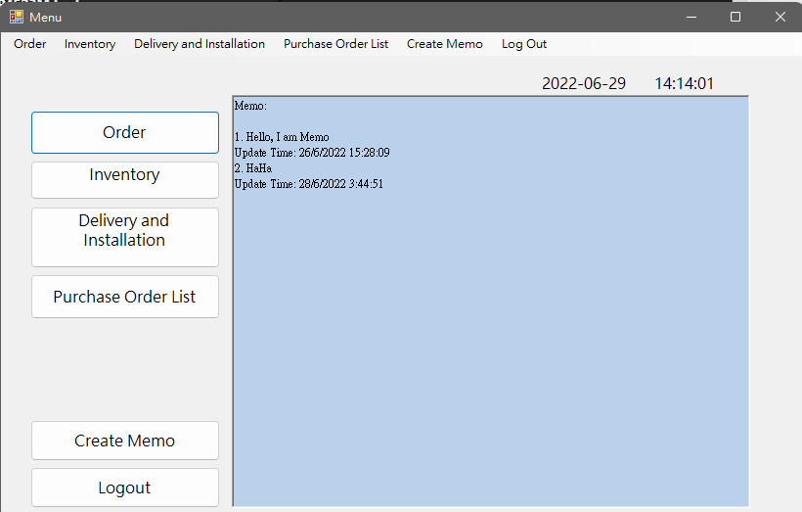

Menu(IT staff)

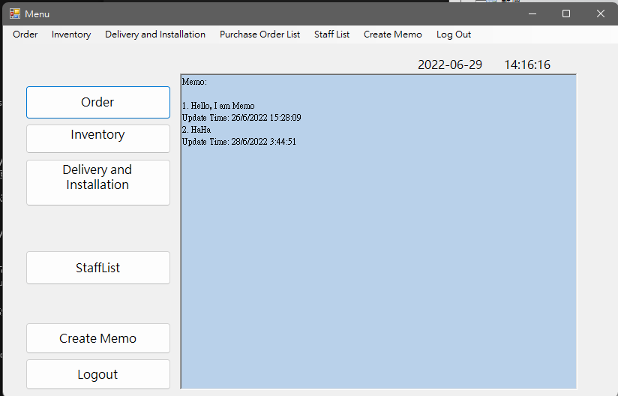

Order (CEO)

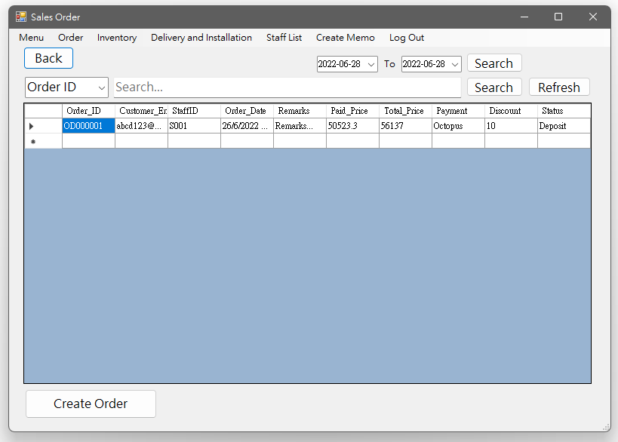

Order (Staff)

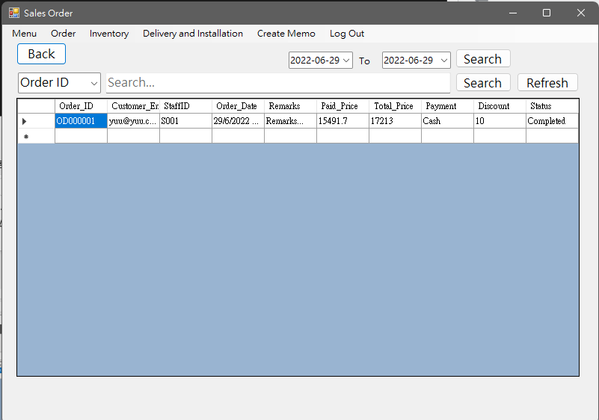

Order detail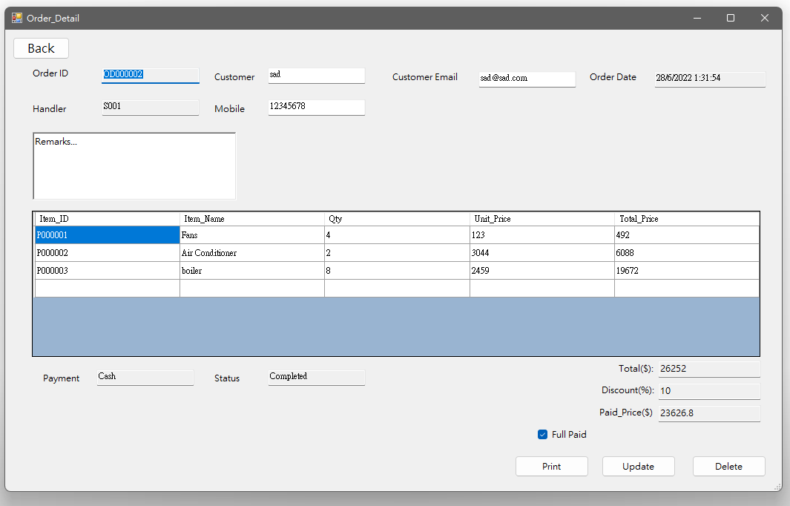

Create Order (CEO)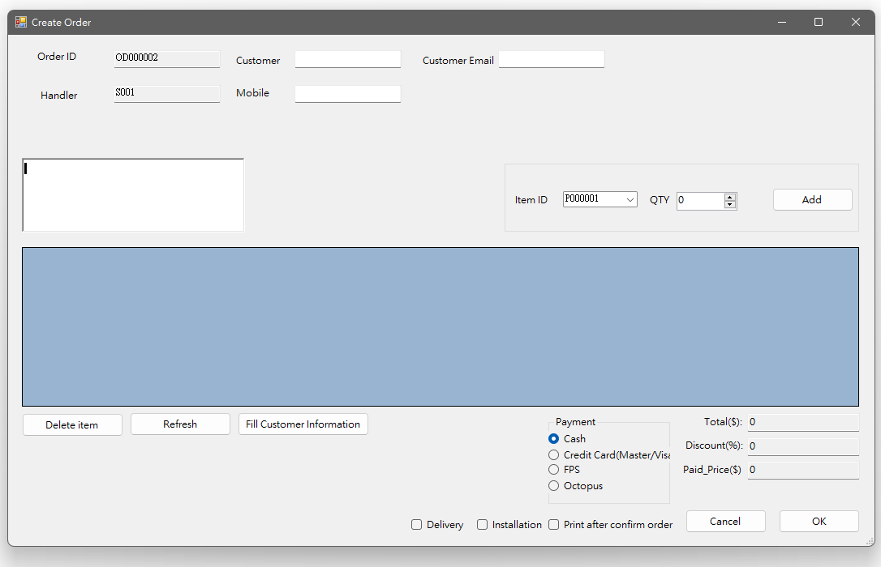

Inventory(CEO, Inventory staff)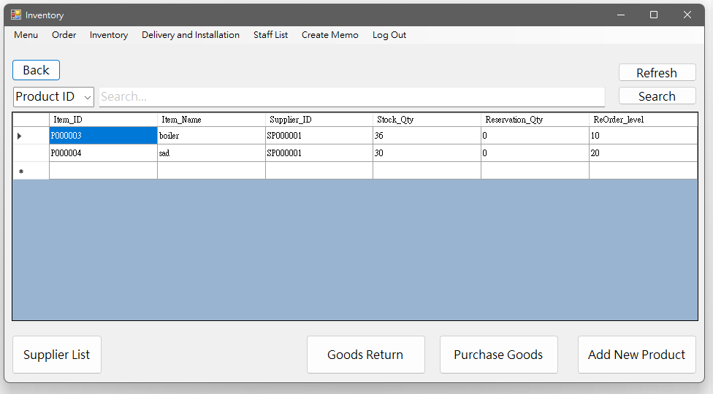

Inventory (staff)

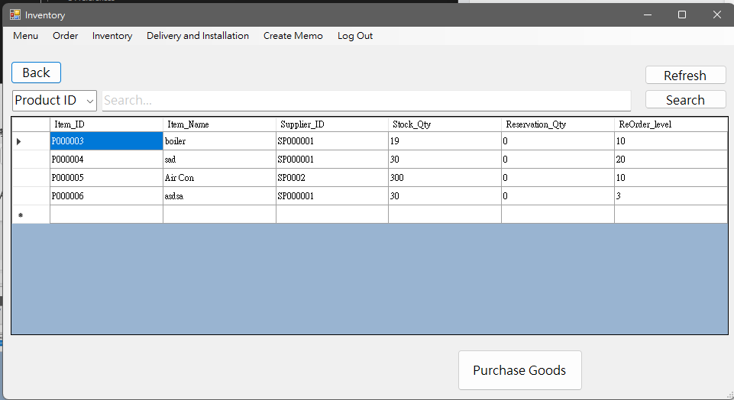

Goods Return(CEO)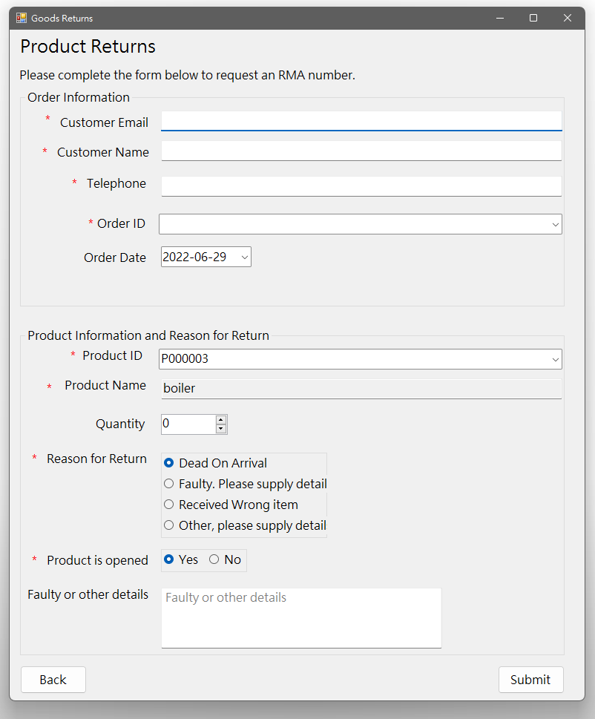

Purchase goods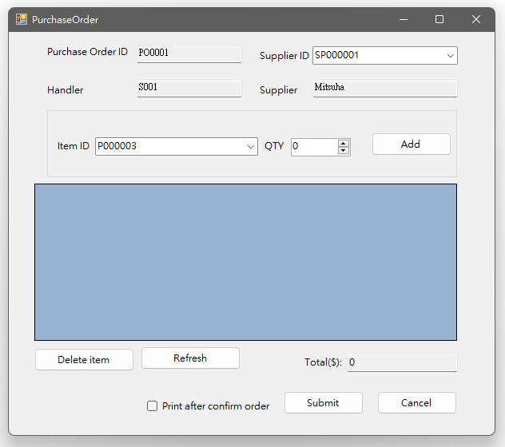

Purchase item detail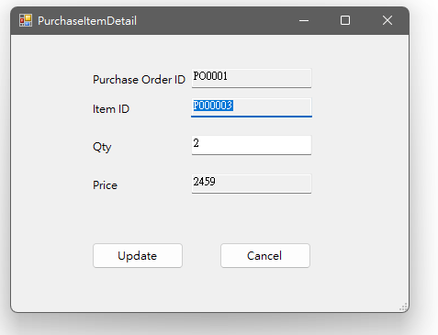

Supplier list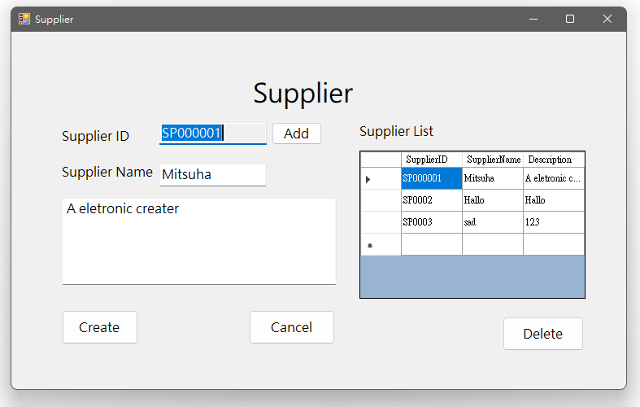

Create product (CEO)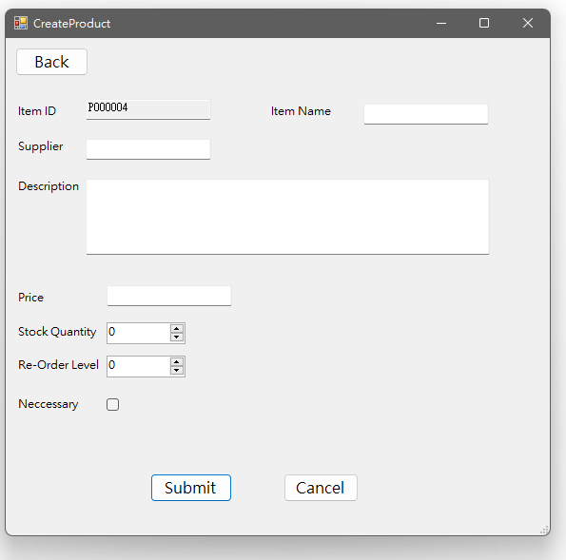

Product detail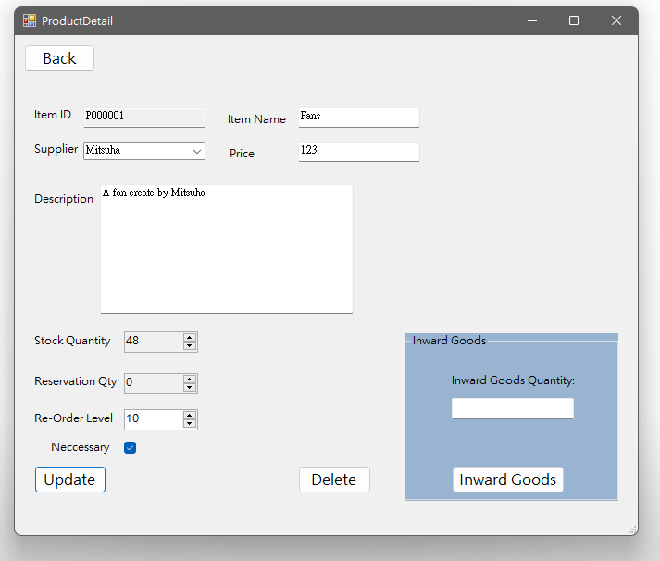

Delivery and Installation (CEO)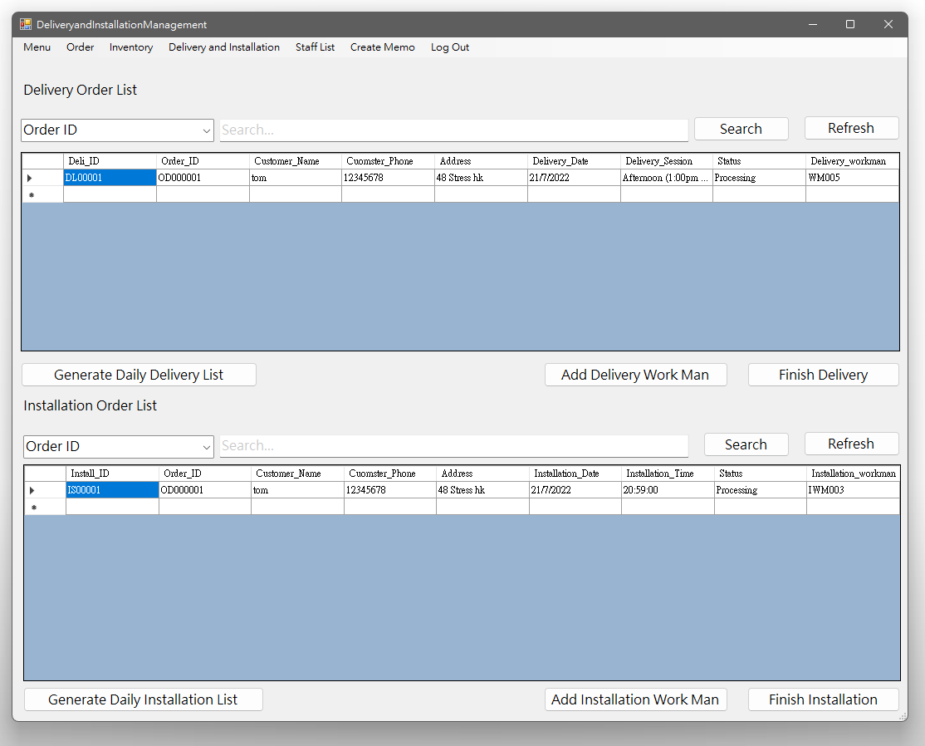

Delivery and Installation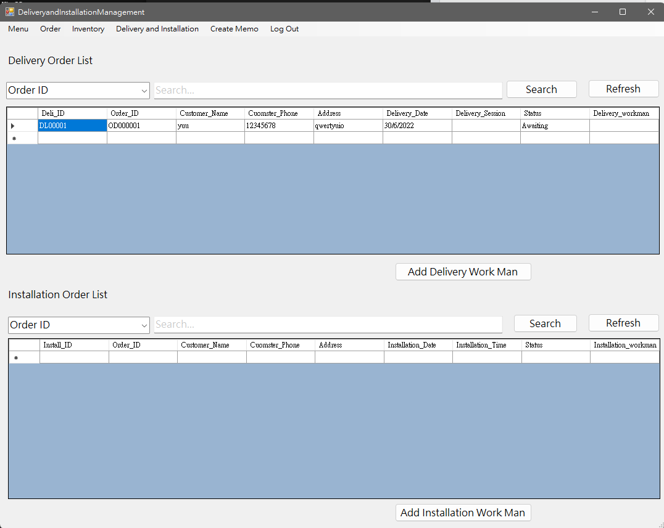

Add delivery work man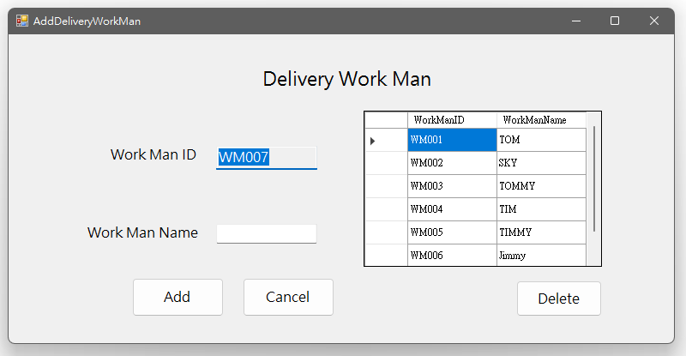

Delivery detail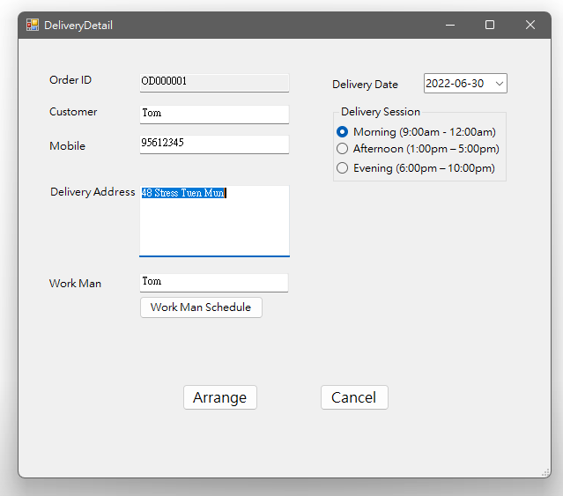

Purchase order list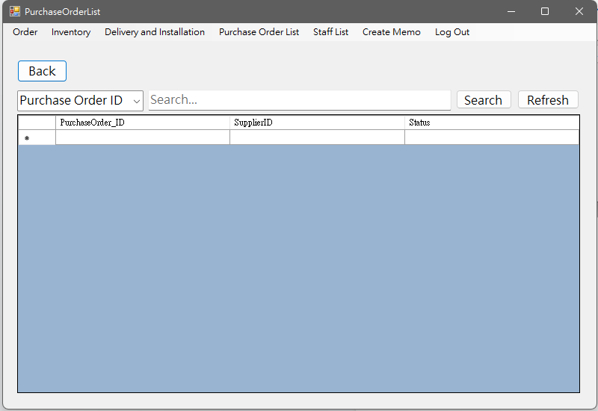

Purchase order detail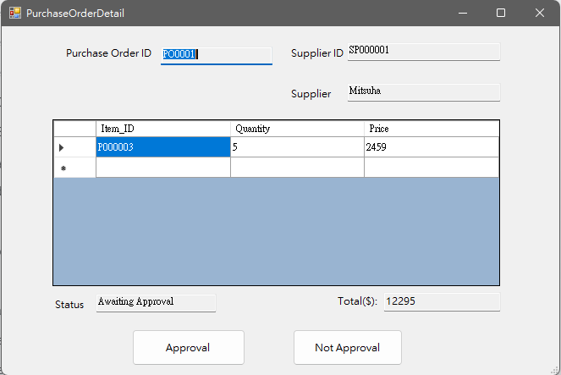

Staff list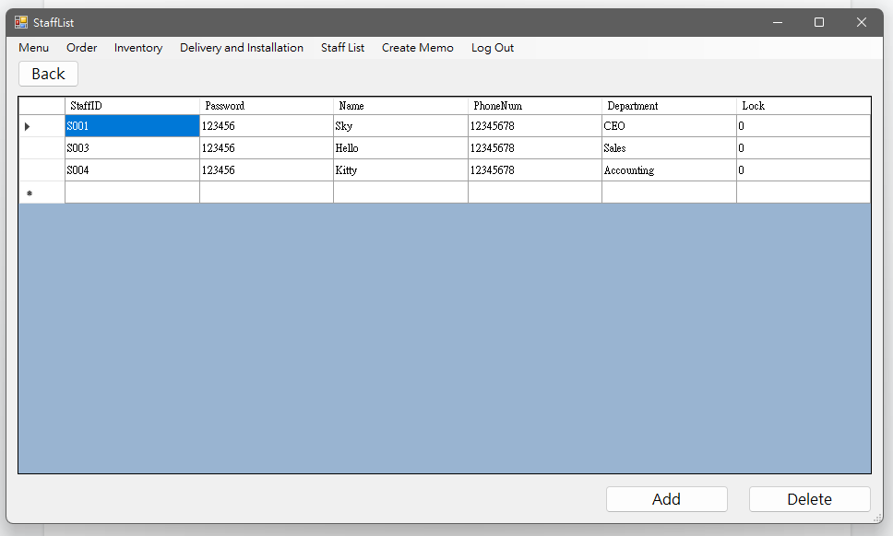

Edit staff information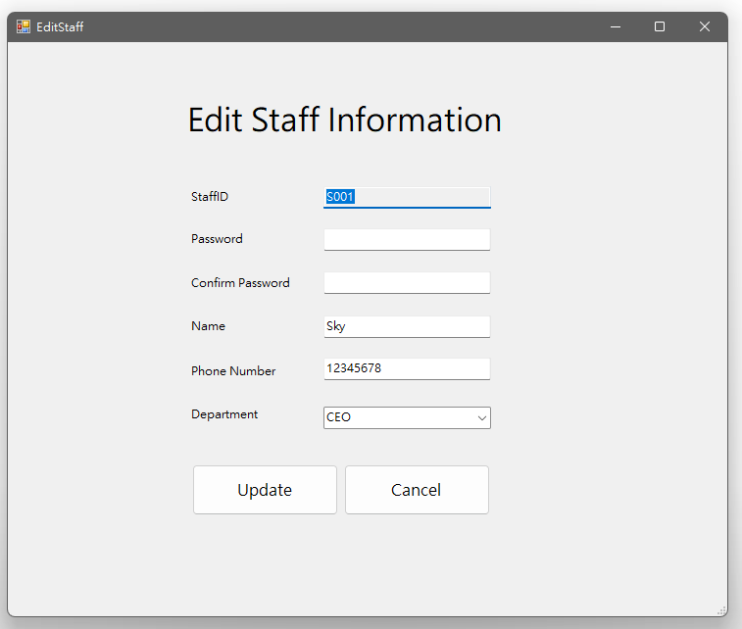

Register account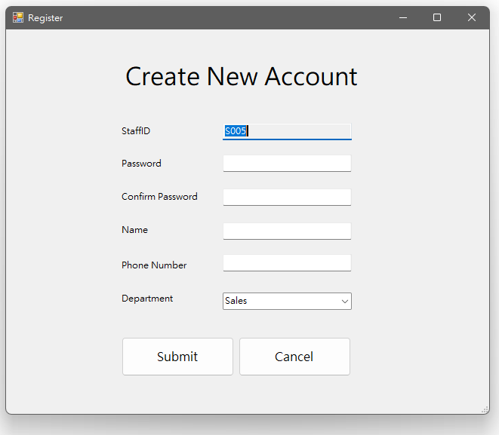

Create memo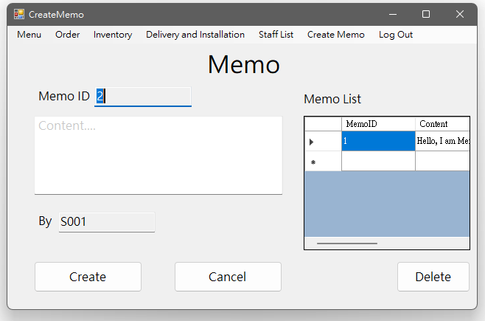

## 6.7 Test case

#### Login and Logout

|  |  |
| --- | --- |
| Test Case Number | TC001 |
| Testing Items | The following items are used to check the login function.   1. Enter a valid staffID and password 2. Click “Login” button |
| Expected Result | * User can login successfully * The system will show a “Login success” message box * The system shows the menu |
| Actual Result | After clicking the “Login” button, the system shows the “Login success” message box, then shows the menu. |

|  |  |
| --- | --- |
| Test Case Number | TC002 |
| Testing Items | The following items are used to check the login function.   1. Enter a invalid staffID / password (either one or both) 2. Click “Login” button |
| Expected Result | * User login unsuccessfully * The system will show a “No Account available with this StaffID and Password” message box |
| Actual Result | After clicking the “Login” button, the error message box is shown. |

|  |  |
| --- | --- |
| Test Case Number | TC003 |
| Testing Items | The following items are used to check the login function.   1. Not enter any value in field / or have some empty field 2. Click “Login” button |
| Expected Result | * User login unsuccessfully * The system will show a “Please enter value in all field” message box |
| Actual Result | After clicking the “Login” button, the error message box is shown. |

|  |  |
| --- | --- |
| Test Case Number | TC004 |
| Testing Items | The following items are used to check the logout function.   1. Click “Logout” button |
| Expected Result | * User logout successfully |
| Actual Result | After clicking the “Logout” button, the system shows the login page. |

#### Change password

|  |  |
| --- | --- |
| Test Case Number | TC010 |
| Testing Items | The following items are used to check the change password function.   1. Enter valid StaffID, Old Password, New Password and the Confirm Password 2. Click “Change Password” button |
| Expected Result | * User can change password successfully * The system will show a “Password Changed” message box |
| Actual Result | After clicking the “Change Password” button, the “Password Changed” message box is shown. |

|  |  |
| --- | --- |
| Test Case Number | TC011 |
| Testing Items | The following items are used to check the change password function.   1. Enter invalid StaffID, Old Password, New Password , Confirm Password (either one or both) 2. Click “Change Password” button |
| Expected Result | * User change password unsuccessfully * The system will show a “Account or Password not correct, Please confirm your account information” message box |
| Actual Result | After clicking the “Change Password” button, the error message box is shown. |

|  |  |
| --- | --- |
| Test Case Number | TC012 |
| Testing Items | The following items are used to check the change password function.   1. Not enter any value in field / or have some empty field 2. Click “Change Password” button |
| Expected Result | * User change password unsuccessfully * The system will show a “Please enter value in all field” message box |
| Actual Result | After clicking the “Change Password” button, the error message box is shown. |

#### Sales Order (search)

|  |  |
| --- | --- |
| Test Case Number | TC020 |
| Testing Items | The following items are used to check the search function of the menu of sales order.   1. Enter Order ID or Customer Email or date in the search field 2. Click “Search” button |
| Expected Result | * User can search the related order. |
| Actual Result | After clicking the “Search” button, the related order is shown on the gridview. |

|  |  |
| --- | --- |
| Test Case Number | TC021 |
| Testing Items | The following items are used to check the search function of the menu of sales order.   1. Enter unknown data in the search field 2. Click “Search” button |
| Expected Result | * User cannot search any data |
| Actual Result | After clicking the “Search” button, no data is shown in the gridview. |

|  |  |
| --- | --- |
| Test Case Number | TC022 |
| Testing Items | The following items are used to check the refresh function on the menu of sales order.   1. After using the search function 2. User the “Refresh” button |
| Expected Result | * All data have been entered in the searching bar will be cleared * GridView will shown all the order detail |
| Actual Result | After clicking “Refresh” button, all the order with detail will shown on the gridview |

#### Sales Order (create)

|  |  |
| --- | --- |
| Test Case Number | TC023 |
| Testing Items | The following items are used to check the create order function of sales order.   1. Enter customer name, customer email and phone number 2. Select item by item ID 3. Select item quantity 4. Click “Add” button 5. Choose payment 6. Click delivery checkbox 7. Enter delivery address and choose delivery date 8. Click “OK” button |
| Expected Result | * User can create an order successfully * A message box shows “Order created. Your Order ID is” with the order ID * A delivery will be created |
| Actual Result | After entering all details and clicking the “OK” button, a message box shows the order created with the order ID, and the delivery created. |

|  |  |
| --- | --- |
| Test Case Number | TC024 |
| Testing Items | The following items are used to check the create order function of sales order.   1. Enter customer name, customer email and phone number 2. Select item by item ID 3. Select item quantity 4. Click “Add” button 5. Choose payment 6. Click “OK” button |
| Expected Result | * User can create an order successfully * A message box shows “Order created. Your Order ID is” with the order ID * A delivery will be created |
| Actual Result | After entering all details and clicking the “OK” button, a message box shows the order created with the order ID. |

|  |  |
| --- | --- |
| Test Case Number | TC025 |
| Testing Items | The following items are used to check the create order function of sales order.   1. Enter the customer email 2. Click “Fill Customer Information” button 3. Select item by item ID 4. Select item quantity 5. CLick “Add” button 6. Choose payment 7. Click “OK” button |
| Expected Result | * User can create an order successfully * Customer name and mobile will automatically fill in. * A message box shows “Order created. Your Order ID is” with the order ID |
| Actual Result | After entering the email and clicking the “Fill Customer Information” button, the customer information automatically fills and clicking the “OK” button, a message box shows the order created with the order ID. |

|  |  |
| --- | --- |
| Test Case Number | TC026 |
| Testing Items | The following items are used to check the create order function of sales order.   1. Not enter customer name, customer email, mobile(either 1 or all) 2. Select item by item ID 3. Select item quantity 4. Click “Add” button 5. Choose payment 6. Click “OK” button |
| Expected Result | * User create order unsuccessfully * A message box shows ”Please enter customer name and mobile number” |
| Actual Result | After clicking the “OK” button, a message box shows to remind the user to enter the information. |

|  |  |
| --- | --- |
| Test Case Number | TC027 |
| Testing Items | The following items are used to check the create order function of sales order.   1. Enter the customer name and mobile 2. Enter an invalid email 3. Select item by item ID 4. Select item quantity 5. CLick “Add” button 6. Choose payment 7. Click “OK” button |
| Expected Result | * User create order unsuccessfully * A message box shows ”Please enter a valid email” |
| Actual Result | After clicking the “OK” button, a message box shows to remind the user to enter the correct email address. |

|  |  |
| --- | --- |
| Test Case Number | TC028 |
| Testing Items | The following items are used to check the create order function of sales order.   1. Enter the customer name and customer email 2. Enter an number with less than 8 digit 3. Select item by item ID 4. Select item quantity 5. CLick “Add” button 6. Choose payment 7. Click “OK” button |
| Expected Result | * User create order unsuccessfully * A message box shows ”Please enter valid phone number at least 8 digit” |
| Actual Result | After clicking the “OK” button, a message box shows to remind the user to enter the correct mobile number. |

|  |  |
| --- | --- |
| Test Case Number | TC029 |
| Testing Items | The following items are used to check the create order function of sales order.   1. Enter a customer email that never use for order 2. Click “Fill Customer Information” button 3. Select item by item ID 4. Select item quantity 5. CLick “Add” button 6. Choose payment 7. Click “OK” button |
| Expected Result | * User create an order unsuccessfully * A message box shows “never buy product from our company” |
| Actual Result | After entering the email and click the “Fill Customer Information” button, the error message box will prompt out. |

#### Sales Order (modify)

|  |  |
| --- | --- |
| Test Case Number | TC030 |
| Testing Items | The following items are used to check the update order detail function of sales order.   1. Modify customer name and mobile 2. Click “Update” button 3. Click yes button |
| Expected Result | * User can update order successfully |
| Actual Result | After modifying the information of customer then click “Update” button, a prompt window ask user if user want to update the record, then click yes button, the order will be updated |

|  |  |
| --- | --- |
| Test Case Number | TC031 |
| Testing Items | The following items are used to check the update order detail function of sales order.   1. Clear customer name and mobile(either 1 or both) 2. Click “Update” button 3. Click yes button |
| Expected Result | * User update order unsuccessfully * An alert will prompt out “Please fill all customer information” |
| Actual Result | After clear the information of customer then click “Update” button, an alert will prompt out and told user to fill in all the information. |

|  |  |
| --- | --- |
| Test Case Number | TC032 |
| Testing Items | The following items are used to check the delete order detail function of sales order.   1. Click “Delete” button 2. Click yes button |
| Expected Result | * User can delete order successfully |
| Actual Result | After clicking the delete button, a promt window ask user if user sure to cancel the record, then click yes button, the orser will be deleted. |

|  |  |
| --- | --- |
| Test Case Number | TC033 |
| Testing Items | The following items are used to check the delete order detail function of sales order.   1. Click “Print” button 2. Click yes button |
| Expected Result | * User can print order successfully |
| Actual Result | After clicking the delete button, a promt window ask user if user sure to export the PDF, then click yes button, the orser will be printed. |

#### 

#### Inventory management(Search)

|  |  |
| --- | --- |
| Test Case Number | TC041 |
| Testing Items | The following items are used to check search item information via Product ID.  productID:P000003 |
| Expected Result | * User checked item information by Product ID P000003 successfully. |
| Actual Result | After enter the Product ID and click search, the product just list ProductID P000003 information |

|  |  |
| --- | --- |
| Test Case Number | TC042 |
| Testing Items | The following items are used to check search item information via a invalid ProductID. |
| Expected Result | * User checked nothing via a invalid ProductID. |
| Actual Result | After enter the Product ID and click search, the product list shows nothing information. |

|  |  |
| --- | --- |
| Test Case Number | TC043 |
| Testing Items | The following items are used to check the refresh function the menu of inventory list.  1.After using the search function  2.User the “Refresh” button |
| Expected Result | * All data have been entered in the searching bar will be cleared * GridView will shown all the order detail |
| Actual Result | After clicking “Refresh” button, all the order with detail will shown on the gridview |

#### 

#### Inventory management(add new product)

|  |  |
| --- | --- |
| Test Case Number | TC044 |
| Testing Items | The following items are used to check the create new product function.  User need to insert following data:   1. Item Name 2. supplier 3. description 4. price 5. stock quantity and re-order level 6. necessary(optional) 7. Description(optional)   and click “submit” button |
| Expected Result | * create new product successfully |
| Actual Result | After entering all data and clicking the “submit” button, the list auto updates the new item and shows all information. |

|  |  |
| --- | --- |
| Test Case Number | TC045 |
| Testing Items | The following items are used to check the create a new product without enter one of them such as  Item name, supplier, Price, stock quantity and reorder level. |
| Expected Result | * create new product not successful. |
| Actual Result | After clicking the “submit” button, system prompt windows said “Please fill in all fields of product ”, click the “ok” to continue entering data. |

|  |  |
| --- | --- |
| Test Case Number | TC046 |
| Testing Items | The following items are used to check the create a new product and enter a new supplier function. |
| Expected Result | * windows prompt user to adding supplier windows. |
| Actual Result | After clicking the “submit” button, system prompt windows ask user to enter the supplier information.  After clicking the “ok” button, system prompt adding new supplier windows to let user enter the new supplier information. |

#### 

#### Inventory management(check/modify item information)

|  |  |
| --- | --- |
| Test Case Number | TC047 |
| Testing Items | The following items are used to check item information.   1. double click the item |
| Expected Result | * system shows the item information window. |
| Actual Result | After double click the item, system prompt the item information, user can checked the information and modify it. |

|  |  |
| --- | --- |
| Test Case Number | TC048 |
| Testing Items | The following items are used to check themodify item information function |
| Expected Result | * modify the item information successfully. |
| Actual Result | After enter one of them the item name, price ,supplier and description, system prompt window ask user confirmation of update information, after click the “ok”, the item list auto update the new information. |

|  |  |
| --- | --- |
| Test Case Number | TC049 |
| Testing Items | The following items are used to check the delete items function.   1. double click the item. 2. system prompts the editing window. 3. click the “delete button” |
| Expected Result | * delete item successfully |
| Actual Result | After clicking the “delete” button, system prompts the confirmation window, after clicking the “yes” button, system prompts the successful window and back to the inventory window, the item is deleted. |

|  |  |
| --- | --- |
| Test Case Number | TC050 |
| Testing Items | The following items are used to check themodify the stock quantity below the re-order level function. |
| Expected Result | * system remind user to purchase the product. |
| Actual Result | after modifying, system prompt remind window. |

## 

#### Delivery and installation(search)

|  |  |
| --- | --- |
| Test Case Number | TC051 |
| Testing Items | The following items are used to check the search item information via OrderID function.  OrderID:OD000001 |
| Expected Result | * User checked item information by OrderID OD000001   successfully. |
| Actual Result | After entering the OrderID and clicking search, the product just lists OrderID OD000001 information. |

|  |  |
| --- | --- |
| Test Case Number | TC052 |
| Testing Items | The following items are used to check the search item information via a invalid Order ID. |
| Expected Result | * User checked nothing via a invalid OrderID. |
| Actual Result | After entering the Order ID and clicking search, the Delivery/Installation list shows nothing information. |

#### Delivery and Installation(arrange)

|  |  |
| --- | --- |
| Test Case Number | TC053 |
| Testing Items | The following items are used to check the arrange the order function.   1. double click the order 2. input customer, mobile, delivery date, delivery session, address and workman. 3. click the “arrange” button. |
| Expected Result | * Users arrange delivery successfully. |
| Actual Result | After entering all needed information and clicking the “Arrange” button, the system prompts a confirmation window, after clicking yes, the order list will auto update the status. |

|  |  |
| --- | --- |
| Test Case Number | TC054 |
| Testing Items | The following items are used to check the arrange the order function.   1. double click the order 2. not to input one of them: customer, mobile, delivery date, delivery session, address and workman. 3. click the “arrange” button. |
| Expected Result | * Users arrange delivery failures. |
| Actual Result | After clicking the “Arrange” button, the system prompts a failure window, and reminds you to input all data. |

|  |  |
| --- | --- |
| Test Case Number | TC055 |
| Testing Items | The following items are used to check the generate daily delivery list function.   1. click the “Generate Daily Delivery List” |
| Expected Result | * users generate a daily delivery list pdf successfully. |
| Actual Result | Clicking the button, the system prompts a confirmation button, after clicking yes, the system auto downloads a daily delivery list to the computer. |

|  |  |
| --- | --- |
| Test Case Number | TC056 |
| Testing Items | The following items are used to check the generated daily installation list function.   1. click the “Generate Daily installation List” |
| Expected Result | * users generate a daily installation list pdf successfully. |
| Actual Result | Clicking the button, the system prompts a confirmation button, after clicking yes, the system auto downloads a daily installation list to the computer. |

#### Purchase order list (search)

|  |  |
| --- | --- |
| Test Case Number | TC060 |
| Testing Items | The following items are used to check the search function of purchase order   1. Choose Purchase Order ID / Supplier ID / Status 2. Put related value into the searching bar 3. Click ‘Search’ button |
| Expected Result | * Users can search the related information successfully |
| Actual Result | After entering the information that users want to search, then press the “Search” button, the related detail will comes out on the GridView. |

|  |  |
| --- | --- |
| Test Case Number | TC061 |
| Testing Items | The following items are used to check the search function of purchase order   1. Choose Purchase Order ID / Supplier ID / Status 2. Put unknown value into the searching bar 3. Click ‘Search’ button |
| Expected Result | * Users can’t search any information |
| Actual Result | After input the unknown information, then press the “Search” button, no information will comes out on the GridView. |

|  |  |
| --- | --- |
| Test Case Number | TC062 |
| Testing Items | The following items are used to check the refresh function of purchase order   1. After serching 2. Click “Refresh” button |
| Expected Result | * Users can refresh the page |
| Actual Result | After seaarching information, press the “Refresh” button, the GridView will shows all the purchase order with detail. |

#### Purchase order detail

|  |  |
| --- | --- |
| Test Case Number | TC063 |
| Testing Items | The following items are used to check the change status function of purchase order detail   1. Click “Approval” button 2. Click yes button |
| Expected Result | * Users can change status successfully * a purchase order ntoes will be generated |
| Actual Result | After clicking “Approval” button, an prompt window will ask user “Do you want to generate a Purchase Order Notes”, then click the yes button, a purchase order note generated. |

|  |  |
| --- | --- |
| Test Case Number | TC064 |
| Testing Items | The following items are used to check the change status function of purchase order detail   1. Click “Approval” button 2. Click no button |
| Expected Result | * Users can change status successfully |
| Actual Result | After clicking “Approval” button, an prompt window will ask user “Do you want to generate a Purchase Order Notes”, then click the no button, a purchase order note will not be generated, the status changed. |

|  |  |
| --- | --- |
| Test Case Number | TC065 |
| Testing Items | The following items are used to check the change status function of purchase order detail   1. Click “ Not Approval” button |
| Expected Result | * Users can change status successfully |
| Actual Result | After clicking “Not Approval” button, the status changed. |

#### Staff List

|  |  |
| --- | --- |
| Test Case Number | TC071 |
| Testing Items | The following items are used to check the add staff account function.   1. Enter a valid staffID 2. Enter a valid DeptID 3. Enter a valid name of staff 4. Enter a valid phone number of staff 5. Enter a valid email of staff 6. Enter a valid position of staff 7. Click “Add” button |
| Expected Result | * The staff is added to the Staff List successfully * The inputted information is displayed horizontally |
| Actual Result | After clicking the “Add” button, the staff is added to the Staff List successfully and the inputted information is displayed horizontally. |

|  |  |
| --- | --- |
| Test Case Number | TC072 |
| Testing Items | The following items are used to check the delete staff function.   1. Enter staff information to add the staff to Staff List 2. Click “Add” button 3. Select the row with StaffID S003 to delete 4. Click “Delete” button |
| Expected Result | * A message box “Do you want to Delete S003 Data?” will be show * If the user click “Yes”, a message box "You have delete S003 Staff Data" will be show |
| Actual Result | After clicking the “Delete” button, the system shows the message box “Do you want to Delete S003 Data?”, then the user clicking the “Yes” button, the message box "You have delete S003 Staff Data" shown. |

|  |  |
| --- | --- |
| Test Case Number | TC073 |
| Testing Items | The following items are used to check the delete staff function.   1. Enter staff information to add the staff to Staff List 2. Click “Add” button 3. Select the row with StaffID S003 to delete 4. Click “Delete” button |
| Expected Result | * A message box “Do you want to Delete S003 Data?” will be show * If the user click “No”, the system will bring the user back to the previous page |
| Actual Result | After clicking the “Delete” button, the system shows the message box “Do you want to Delete S003 Data?”, then the user clicks the “No” button, the system brings the user back to the previous page. |

#### 

#### 

#### 

#### Edit Staff information

|  |  |
| --- | --- |
| Test Case Number | TC074 |
| Testing Items | The following items are used to check the Edit staff information function.   1. Enter the StaffID S003 2. Click “Yes” of the pop up message box “Do you want to update S003 Data?” 3. Enter the valid new password 4. Enter the valid new password correctly again to confirm 5. Enter the Staff Name 6. Enter the phone number of the staff 7. Elect the Department of the staff 8. Click the “Update” button |
| Expected Result | * The staff information changed * A message box “You have update S003 Data!” will show |
| Actual Result | After clicking the “Update” button, the staff information of Staff S003 is changed and the message box is shown. |

|  |  |
| --- | --- |
| Test Case Number | TC075 |
| Testing Items | The following items are used to check the Edit staff information function.   1. Enter the StaffID S003 2. Click “No” of the pop up message box “Do you want to update S003 Data?” |
| Expected Result | * The staff information cannot change * A message box “Please confirm your information” will show |
| Actual Result | After clicking the “No” button, the staff information of Staff S003 has no change and the message box is shown. |

|  |  |
| --- | --- |
| Test Case Number | TC076 |
| Testing Items | The following items are used to check the Edit staff information function.   1. Enter the StaffID S003 2. Click “Yes” of the pop up message box “Do you want to update S003 Data?” 3. Enter the valid new password 4. Enter the invalid new password correctly again to confirm 5. Enter the Staff Name 6. Enter the phone number of the staff 7. Select the Department of the staff 8. Click the “Update” button |
| Expected Result | * The staff information cannot be changed * An error message box “Please confirm your password, confirm password and password should be same” will show |
| Actual Result | After clicking the “Update” button, the staff information of Staff S003 cannot be changed and the error message box is shown. |

|  |  |
| --- | --- |
| Test Case Number | TC077 |
| Testing Items | The following items are used to check the Edit staff information function.   1. Enter the StaffID S003 2. Click “Yes” of the pop up message box “Do you want to update S003 Data?” 3. Enter the valid new password 4. Enter the valid new password correctly again to confirm 5. Enter the phone number of the staff 6. Elect the Department of the staff 7. Click the “Update” button |
| Expected Result | * The staff information cannot be changed * A message box “Please fill all the field” will show |
| Actual Result | After clicking the “Update” button, the staff information of Staff S003 cannot be changed and the error message box is shown. |

|  |  |
| --- | --- |
| Test Case Number | TC078 |
| Testing Items | The following items are used to check the Edit staff information function.   1. Enter the StaffID S003 2. Click “Yes” of the pop up message box “Do you want to update S003 Data?” 3. Enter the valid new password 4. Enter the valid new password correctly again to confirm 5. Enter the Staff Name 6. Enter the phone number of the staff 7. Elect the Department of the staff 8. Click the “Cancel” button |
| Expected Result | * The inputted staff information is clear |
| Actual Result | After clicking the “Cancel” button, the inputted staff information of Staff S003 is clear. |

#### 

#### Memo

|  |  |
| --- | --- |
| Test Case Number | TC080 |
| Testing Items | The following items are used to check the create memo function.   1. Enter the Memo ID 2. Enter the required content 3. Enter the Staff ID of the user 4. Click the “Create” button |
| Expected Result | * The memo added and the data of memo show on the memo list * A successful message box “Your Memo created!” will be show |
| Actual Result | After clicking the “Create” button, the memo added and the memo with MemoID, content, StaffID and memo date show on the memo list.  A successful message box is shown. |

|  |  |
| --- | --- |
| Test Case Number | TC081 |
| Testing Items | The following items are used to check the create memo function.   1. Enter the Memo ID 2. Enter the Staff ID of the user 3. Click the “Create” button |
| Expected Result | * The memo cannot be created * A message box “Please enter your memo content!" will be show |
| Actual Result | After clicking the “Create” button, the system shows a message box “Please enter your memo content!" to remind the user.  The memo cannot be created. |

|  |  |
| --- | --- |
| Test Case Number | TC082 |
| Testing Items | The following items are used to check the create memo function.   1. Enter the Memo ID 2. Enter the required content 3. Enter the Staff ID of the user 4. Click the “Cancel” button |
| Expected Result | * All of the input data is cleared * The memo could not be generated |
| Actual Result | After clicking the “Cancel” button, the input data (Memo ID, content, StaffID) is cleared.  The memo cannot be generated. |

|  |  |
| --- | --- |
| Test Case Number | TC083 |
| Testing Items | The following items are used to check the delete memo function.   1. Enter the Memo ID 2. Enter the required content 3. Enter the Staff ID of the user 4. Click the “Create” button to create the memo 5. Select the memo 6. Click the “Delete” button |
| Expected Result | * The selected memo has been deleted from the Memo List |
| Actual Result | After clicking the “Delete” button, the generated memo is deleted from the Memo List. |

|  |  |
| --- | --- |
| Test Case Number | TC084 |
| Testing Items | The following items are used to check the delete memo function.   1. Enter the Memo ID 2. Enter the required content 3. Enter the Staff ID of the user 4. Click the “Create” button to create the memo 5. Click the “Delete” button |
| Expected Result | * Memo cannot be deleted from the Memo List * An error message box “Deleted failed” will show |
| Actual Result | After clicking the “Delete” button, the generated memo cannot be deleted from the Memo List and the error message shown. |

## 

## 6.8 User Guide

### 6.8.1 - Installation

To use the software, it has to be installed.

Run the installer and Follow the steps,

After it is installed, launch the software to use it.

### 6.8.2 - general guide for all users

#### Login

After the software is launched, the system prompts the login window,

input the staffID and password then click the “login’ button.

After the user logs in successfully, the system prompts the menu window, and the user can see the memo function. For each user account type, a different set of buttons will appear in the navigation bar on the top and menu window. users click the button to use different functions in this software. More details for each of the buttons for different accounts can be referred to their account type below.

#### Logout

Users can click the “logout” button in the navigation bar or menu window, after clicking the “logout” button, the system will prompt the login window, users need to enter the staffID and password to login.

#### Change password

User can click the “change password” button at the login window, after clicking it, system will prompt a change password window, user input the staffID, old password, new password and confirmation password then click “change password” button, after clicking it, the account will prompt a successful window, and then user can use the new password to login.

### 6.8.3 - guide for CEO type users

After the CEO user logged in to the system, the CEO user can use all the functions in the system, including modifying staff and product information, etc. And the Staff List function is only the CEO users have permission to use.

#### Staff List

A CEO user can add a staff member to the Staff List by entering the staff’s information. If a staff member no longer belongs to the company, the CEO user can also delete the employee's information from the system through the "Delete" function of the Staff List.

### 

### 6.8.4 - guide for Sales/Account type users

For the Orders function, users who have a Sales Account are able to use this function. There are two parts of this function.

First, the order viewing part. Users have two search methods, search by date or search by Order ID.

1. Users can select a period of date, after clicking the “Search” button, all orders placed during that period will be displayed.

2. Users can directly enter the order number to query the specified order.

Regardless of the search method, the results will display the following information:

1. Order ID
2. Customer ID
3. Item ID
4. order date
5. remarks
6. paid price
7. total price
8. payment
9. discount
10. status of orders

Second, is the order details part. The user can enter the Order ID to view the order details.

Order details include the information which can be found on the search order page. It also shows the information of the customer, such as customer email and phone number. As a result, the data of the ordered item will be displayed:

1. Item ID
2. Item Name
3. Quantity
4. Unit price
5. Total price

If the order is fully paid, the user can click the checkbox to mark.

The user can click the “Print” button to print the order for record, or click the “Update” button to update any information except the Order ID of the order.

The user can also select more than one order and click the “Delete” button to delete the selected order.

### 6.8.5 - guide for inventory type users

#### 1.Inventory interface

inventory type users can read, modify and add new products.

##### Add new product

inventory users can click the “add new product” button to go to the Create product interface,

users can input the Item name, supplier, description, price, stock quantity and re-order level, also Description and clicking box “Necessary” is an optional box, users can choose to not input it.

After inputting all needed data, the user clicks the “submit” button to add a new product, when the user clicks it, the system prompts a confirmation window to make sure you are creating a new product, click “yes” to create a new product.

If users input a non-existing supplier, the system will prompt a window to remind you the supplier does not exist in the system, and then the system will prompt a create new supplier window, input suppliers can description and click the “submit” button to add a new supplier.

##### Modify product

In the inventory interface, users can double click the item, the system will prompt the product detail window, users can check the Item name, supplier, description, price, stock quantity, re-order level.

Users can modify the data in this interface, and click the update button, the system will prompt the confirmation window, after clicking the yes button, the item detail will be updated.

##### 

##### Delete

In the inventory interface, users can double click the item, the system will prompt the product detail window, users can check the Item name, supplier, description, price, stock quantity, re-order level.

Users can delete the item by clicking the “delete” button, the system will prompt a confirmation window, after clicking the yes button, the item will be deleted.

##### Search

In the inventory interface, users can input the productID in the search bar to search the item detail.

After the user finishes their searching, the user can click the “refresh” button to refresh the product list.

#### 2.Delivery and installation

In the delivery and installation interface, inventory type users can

##### Search

In the delivery and installation interface, users can input the orderID in the search bar to search the item detail.

After the user finishes their searching, the user can click the “refresh” button to refresh the order list.

##### Modify order list

In the delivery and installation interface, users can double click the order to go to the modified order list interface.

Users can input the customer, mobile, delivery date, delivery session, address and workmen and click the button”arrange”.

Users can modify the data in this interface, and click the arrange button, the system will prompt the confirmation window, after clicking the yes button, the order detail will be updated.

##### Generate Daily Delivery/installation list

In the delivery and installation interface, users can click the “generate daily delivery list” or “generate daily installation list”.

Clicking the button will prompt a confirmation window, after clicking yes, the system auto downloads a Daily Delivery/installation list pdf in the computer.

### 6.8.6 - IT Staff

Below is the list of software that needs to be installed before the staff can build and debug the program:

MySQL Workbench: https://dev.mysql.com/downloads/workbench/

MySQL for Visual Studio: https://dev.mysql.com/downloads/windows/visualstudio/

MySQL Connector .NET: https://dev.mysql.com/downloads/connector/net/

Microsoft .NET: https://dotnet.microsoft.com/download

Microsoft Visual Studio 2019: https://visualstudio.microsoft.com/vs/

## 6.9 Project Schedule

|  |  |  |  |  |  |
| --- | --- | --- | --- | --- | --- |
| Task ID | Task Name | Estimated | | | Dependency |
| Duration (days) | Start Date | Finish Date |
| 1 | Abstract | 2 | 25/1 | 26/1 | / |
| 2 | Introduction | 2 | 25/1 | 26/1 | / |
| 3 | Problem Finding | 7 | 27/1 | 2/2 | 1, 2 |
| 4 | Functional Requirements | 22 | 3/2 | 24/2 | 3 |
| 5 | Non-Functional Requirements | 22 | 3/2 | 24/2 | 3 |
| 6 | Conclusion (R.S. report) | 1 | 25/2 | 25/2 | 4, 5 |
| 7 | System Architecture - Hardware | 1 | 4/3 | 4/3 | 6 |
| 8 | System Architecture - Software | 1 | 4/3 | 4/3 | 6 |
| 9 | Network Configuration | 1 | 4/3 | 4/3 | 6 |
| 10 | Constrains and Limitation | 1 | 5/3 | 5/3 | 7, 8, 9 |
| 11 | Actior Description | 2 | 6/3 | 7/3 | 10 |
| 12 | Use Case Diagram | 3 | 8/3 | 10/3 | 11 |
| 13 | Use Case Description | 5 | 11/3 | 15/3 | 12 |
| 14 | Class Diagram | 1 | 16/3 | 16/3 | 13 |
| 15 | Sequence Diagram | 5 | 17/3 | 21/3 | 14 |
| 16 | Entity Relation Diagram | 3 | 22/3 | 24/3 | 15 |
| 17 | Database Design | 5 | 25/3 | 29/3 | 16 |
| 18 | Gantt Chart | 1 | 30/3 | 30/3 | 17 |
| 19 | PERT Chart | 1 | 30/3 | 30/3 | 17 |
| 20 | Conclusion(S.A.D. reprot) | 2 | 31/3 | 1/4 | 18, 19 |
| 21 | Project Log | 1 | 1/4 | 1/4 | 20 |
| 22 | User Interface Design | 3 | 19/5 | 21/5 | 21 |
| 23 | Online System Coding | 21 | 23/5 | 13/6 | 22 |
| 24 | Online System Prototype Test | 2 | 14/6 | 15/6 | 24 |
| 25 | Online System Review and Debug | 5 | 16/6 | 20/6 | 25 |
| 26 | Test case | 4 | 21/6 | 24/6 | 26 |
| 27 | User guide | 1 | 25/6 | 25/6 | 28 |
| 28 | Update - Project Schedule | 1 | 26/6 | 26/6 | 29 |
| 29 | Update - Gantt Chart | 1 | 27/6 | 27/6 | 30 |
| 30 | Update - PERT Chart | 1 | 27/6 | 27/6 | 31 |
| 31 | Update - Project Log | 1 | 27/6 | 27/6 | 32 |
| 32 | Organize the report | 1 | 28/6 | 29/6 | 33 |

### 6.9.1 Gantt Chart

### 6.9.2 PERT Chart

# 7. How ITP4510, ITP4522, ITP4915M modules help us to finish the project?

|  |
| --- |
| Tam Chun Ho  ITP4510 helps us to design the system, we have to plan how to access data and clarify the concept. Also, this module has improved our coding to know how to code up the system function.  ITP4522 helps us plan the schedule or some software and hardware required. Also, we have learned planning skills in this module. When we design the system, this can help us finish the project faster and more conveniently.  ITP4915M has taught us how to use visual studio to connect the database. In the system, we need to access the data in the database many times. Also, we have learn the programming language about C# and how to control the data or insert the data in a visual studio. When we use the visual studio to finish the project, ITP4915M helps us too much.  Combining these 3 modules, I learned that planning before developing the software is most important. If the software plan or spec is well, we can more easily complete the project such as database design. |
| Kwok Hin Fung Anson:  I think ITP4510 improved our coding skills, although I didn't coding in this project too much, I still can know what the codes are doing, to help us develop this system more easily.  I think ITP4522 helps us with teamwork and collaboration, to let us know more about what the system is for, and the relationship between business and IT. Also improved our planning skills, lets us develop the system more systematically.  I think ITP4915M teach us how to use programming language visual studio and C# to develop a system, and the way to connect the database, we have learned many techniques in this module to finish this system. |
| Tam Lok To Andrea:  I think ITP4510 helped us to use more diverse and functional coding. By applying the programming techniques learned here to make our system more complete,    I think ITP4522 helped us to be more organized and professional to complete a project. We are able to apply the analytical skills and related knowledge acquired in this discipline, such as the factors that need to be considered in making a system, how to make the user interface simple and full of required functions.  I think ITP4915M helped us learn how to work as a team to complete a project and write reports, and also taught us how to use C# technology and Visual Studio to develop a system that can be used by the company. |
| Kwan Wai Ying :  I think ITP4510 helps us to structure the data and coding, let us easier to organize the data, such as we can exercise appropriate judgment in planning and controlling software development projects.  ITP4522 helps us to make a report, every stage in the report we can reference this module to make this report, and let this report be completed as much as possible, such as using the 'Gantt Chart' and 'PERT Chart' to illustrate a project schedule.  ITP4915M helps us to make the page, every interface using the form and making them connect, also helps us to make functions like clicking the button to print PDF. In addition, this module also teaches us a new programming language, C#, that we can use in Visual Studio for making pages in this project.  Those 3 modules both help us can do the project smoothly, learn skills to finish this project and reduce the difficulties of doing the project. |

# 

# 8. Conclusion

In conclusion, after the interview with different departments and observation with the current system, we have found what problems happened in the current system and we have analyzed these problems. Thereby find how to create the central computerized management system to fix the problems of the current system.

In this case, companies have too much manual work, this makes work efficiency too low. In this situation, we are going to build a system for staff using computers to help with their work. For example, when an order is completed, staff will use computers to print a receipt, the receipt will note down product information.

Also, we noticed that the PCs are not interconnected in the different centers, data between different centers cannot be readily shared. In this situation, information sharing will be limited. So, we are going to purchase a new server for the installation of the Database server. And we will build a Database system to provide access to data and to help synchronize information between different centers and departments.

Moreover, we also considered the hidden concerns that the company may have such as security problems and system stability. As the system is an important tool for the company, we are going to build a firewall to protect the system from viruses or hackers. Also, we will have a backup power supply in case the main power fails suddenly and the system can not function properly.

In addition, we also analyze how the company can get benefits in the central computerized management system to analyze whether the system is useful to the company. We have determined that the system can help the company improve the efficiency of the store and improve the image, improve the security, improve the communication with different centers and departments, also it can save costs. So, we can be sure that this system will help Better Limited to expand its business.

For future planning, we will analyze how to design this system based on the initial design and write a Design Specification Report. We can get more clarity on what function should be designed and how this system should be designed with the Design Specification Report.

Hoping the system will be useful to Better Limited to expand their business.

# 

# 

# 9. Project Log

|  |  |  |  |  |
| --- | --- | --- | --- | --- |
|  | **Start Date** | **End Date** | **Tasks** | **Person in charge** |
| **Requirement Specification Report** | | | | |
| 1. | 25/1 | 26/1 | Abstract | Tam Chun Ho |
| 2. | 25/1 | 26/1 | Introduction | Tam Chun Ho |
| 3. | 27/1 | 2/2 | Problem Finding | Tam Lok To Andrea |
| 4. | 3/2 | 24/2 | Functional Requirements | Kwok Hing Fung Anson |
| 5. | 3/2 | 24/2 | Non-Functional Requirements | Kwan Wai Ying |
| 6. | 25/2 | 25/2 | Conclusion (R.S. report) | Tam Chun Ho |
| **System Analysis and Design Report** | | | | |
| 7. | 4/3 | 4/3 | System Architecture - Hardware | Kwok Hing Fung Anson |
| 8. | 4/3 | 4/3 | System Architecture - Software | Kwok Hing Fung Anson |
| 9. | 4/3 | 4/3 | Network Configuration | Kwok Hing Fung Anson |
| 10. | 5/3 | 5/3 | Constraints and Limitation | Kwok Hing Fung Anson |
| 11. | 6/3 | 7/3 | System Analysis and Design - Actor Description | Tam Chun Ho |
| 12. | 8/3 | 10/3 | System Analysis and Design - Use Case Diagram | Tam Chun Ho |
| 13. | 11/3 | 15/3 | System Analysis and Design - Use Case Description | Tam Chun Ho |
| 14. | 16/3 | 16/3 | System Analysis and Design - Class Diagram | Tam Lok To Andrea |
| 15. | 17/3 | 21/3 | System Analysis and Design - Sequence Diagram | Tam Chun Ho  Kwok Hing Fung Anson  Kwan Wai Ying |
| 16. | 22/3 | 24/3 | Entity Relation Diagram (ERD) | Tam Lok To Andrea |
| 17. | 25/3 | 29/3 | Database Design | Tam Lok To Andrea |
| 18. | 30/3 | 30/3 | Project Schedule - Gantt Chart | Kwan Wai Ying |
| 19. | 30/3 | 30/3 | Project Schedule - PERT Chart | Kwan Wai Ying |
| 20. | 31/3 | 1/4 | Conclusion (S.A.D. report) | Kwan Wai Ying |
| 21. | 1/4 | 1/4 | Project Log | Kwan Wai Ying |
| **Final Report** | | | | |
| 22. | 19/5 | 21/5 | User Interface Design | Tam Chun Ho  Kwan Wai Ying |
| 23. | 23/5 | 13/6 | Online System Coding | Tam Chun Ho |
| 24. | 14/6 | 15/6 | Online System Prototype Test | Tam Chun Ho |
| 25. | 16/6 | 20/6 | Online System Review and Debug | Tam Chun Ho  Kwan Wai Ying |
| 26. | 21/6 | 24/6 | Test case | Kwan Wai Ying  Kwok Hing Fung Anson  Tam Lok To Andrea |
| 27. | 25/6 | 25/6 | User guide | Kwok Hing Fung Anson  Tam Lok To Andrea |
| 28. | 26/6 | 26/6 | Update - Project Schedule | Kwan Wai Ying |
| 29. | 27/6 | 27/6 | Update - Gantt Chart | Kwan Wai Ying |
| 30. | 27/6 | 27/6 | Update - PERT Chart | Kwan Wai Ying |
| 32. | 27/6 | 27/6 | Update - Project Log | Kwan Wai Ying |
| 33. | 28/6 | 29/6 | Organize the report | All member |